The Sullivan Trail A’s News

“Coming together is a beginning; keeping together is progress; working together is success.”
- Henry Ford
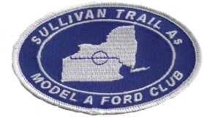 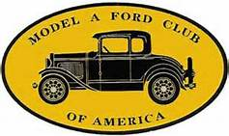 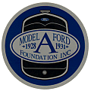 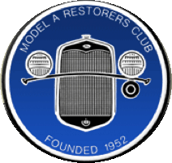 http://www.sullivantrailas.com 1903 1927–1931 September 2015

2008 4,849,340 Produced Volume 8 Issue 7

Yes, it’s coming, so let’s enjoy nice weather while we can!

President

Jim Morris
jim.morris2831@aol.com

Vice President

Doug Archer

Treasurer

Mark Harth
bearfarm14818@gmailcom

Secretary

Beverly Harding
1stmafc@gmail.com

Director At Large

Bill Haag
fingers5n5@aol.com

Newsletter Editor
Jim Morris

Website Liaison

Jerry Wilcox

jerrywilcox55@gmail.com

Webmaster
Mike Horning
mhorningpsu@gmail.com
~~~~~~~~~~~~~~~~~~~~~~

Sullivan Trail A’s Meetings:
- Monthly
- 2nd Tuesday September - June
- 7pm
- United Methodist Church
1034 W Broad St
Horseheads, NY

In This Issue
- From The President’s Garage
- 9-8-15 Meeting Minutes
- Upcoming Events
- Fillmore Glen Car Show Photos
- Did you know …?
- Technical Tip: Backfiring
- MAFCA Membership

FROM THE PRESIDENT’S GARAGE
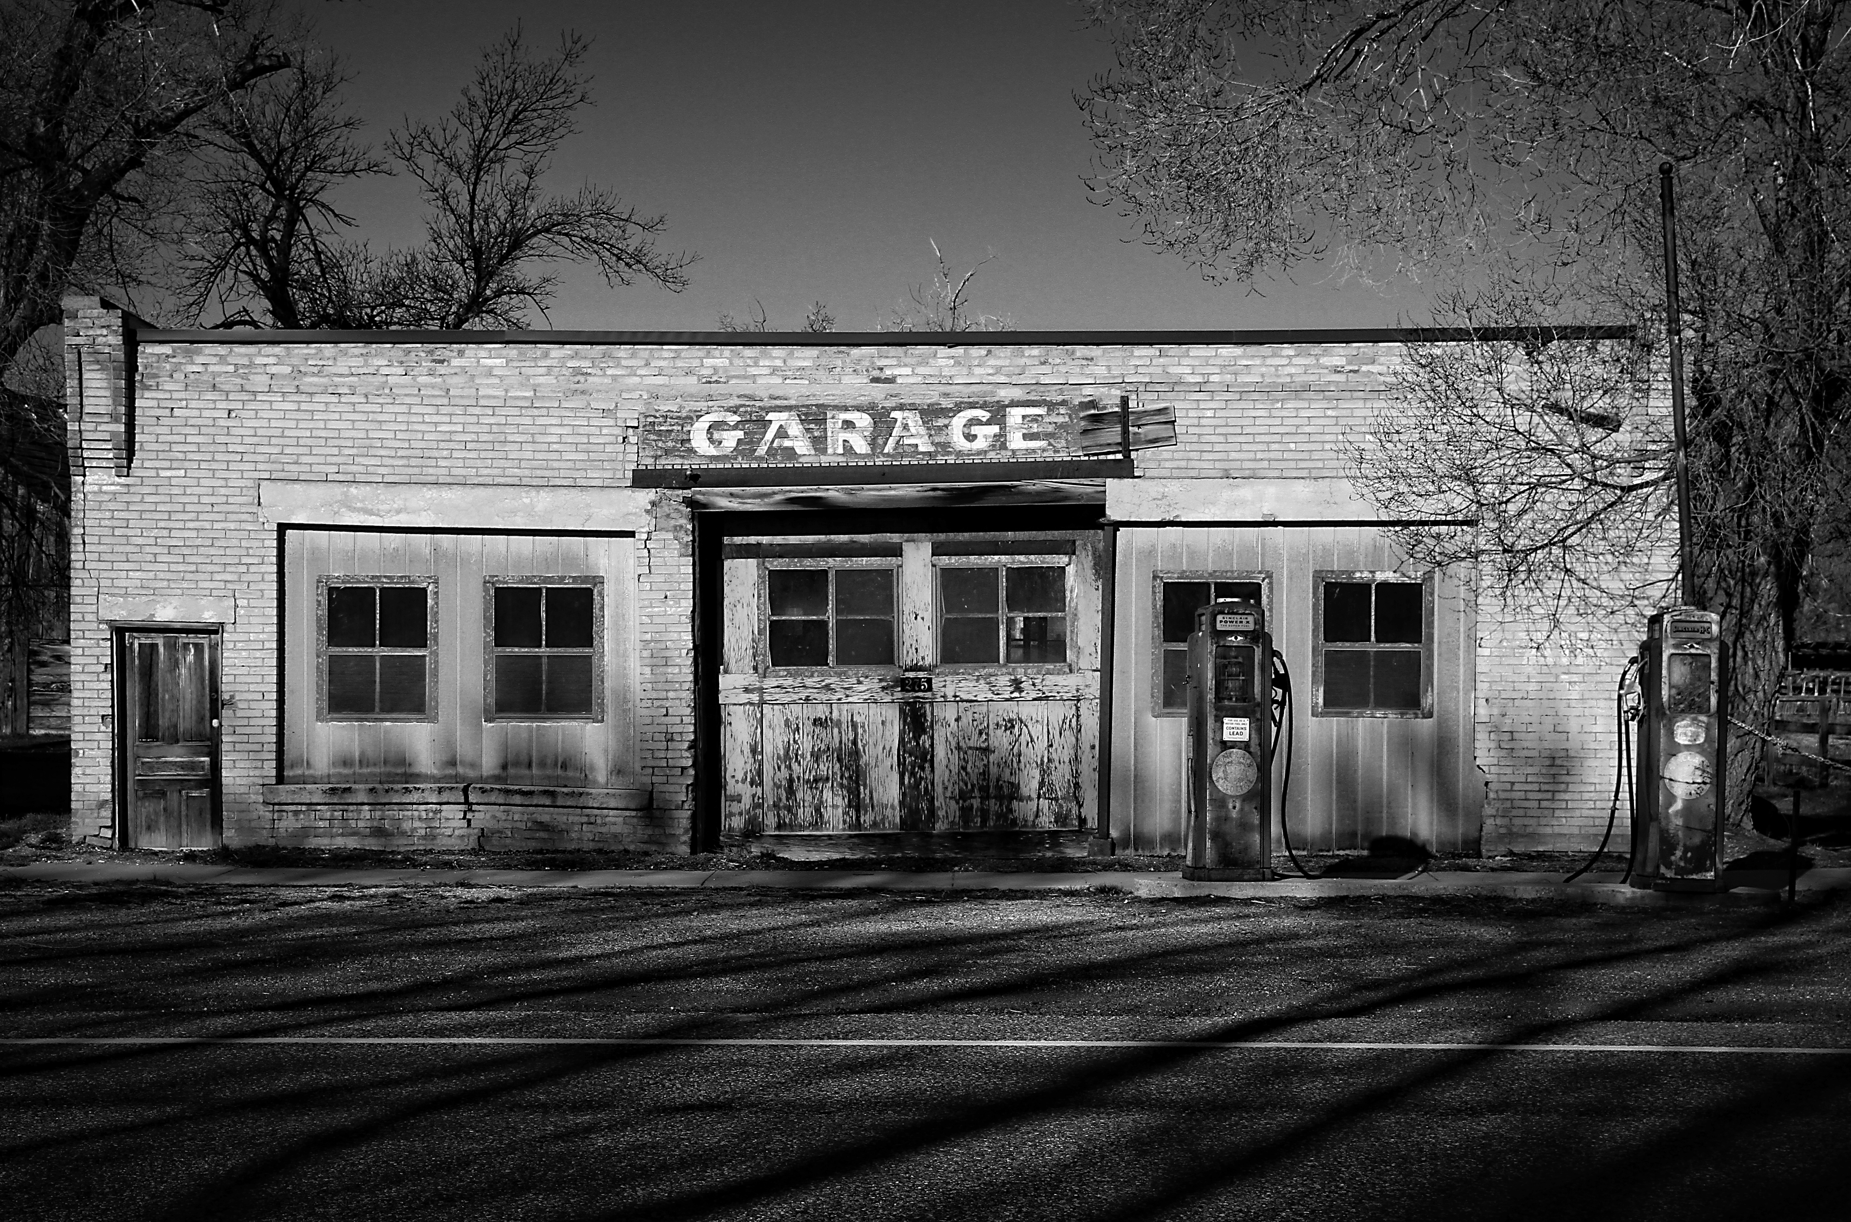

As this issue of our newsletter goes to press the summer is winding down and we’ve had our first meeting of the fall. Hershey is coming up for those of us who make the trek every year and every year I wonder why I go. I don’t need anything anymore so why am I so eager to drive 3-1/2 hours one-way, spend money on a motel room, walk all day looking at flea market spaces, and usually come home empty handed and exhausted? I think there’s no rational answer to that question. As I wander the flea market I’m MIA and removed from the sometimes demanding world I live in, instead, I’m suspended in Hershey’s circus sights and sounds from sausage links frying with onions and peppers to barn-find cars belching blue smoke and everything in between. I see thousands of tools, rusted fenders, 1920s ladies hats, honey for sale, hundreds of license plates, tin cans rattling on pavement behind moving golf carts, and people from all over the globe. I use walking muscles that have been hibernating for weeks. I think that’s the fun of it.. seeing, hearing, smelling, unless it rains. Now and then I find a cheap car part that’s such a huge deal and rare find that I have to have it so I buy it. I have shelves in my garage that have many of these dusty treasures on display for the spiders in my garage to enjoy. Someday I’ll sell these jewels yet I’ll always keep memories of how much fun it was to find them.

International Model A Ford Day is coming up on Saturday September 19th so plan to join Club members for our drive to Cortland for a museum tour and lunch. More on this adventure is detailed in our meeting minutes. We’re also planning to have a tour to Hammondsport, NY the weekend after Hershey, October 17th. We’ll send out more information on the fall tour via a Club email later when we know more.

Enjoy those A’s folk!
All for now, Jim

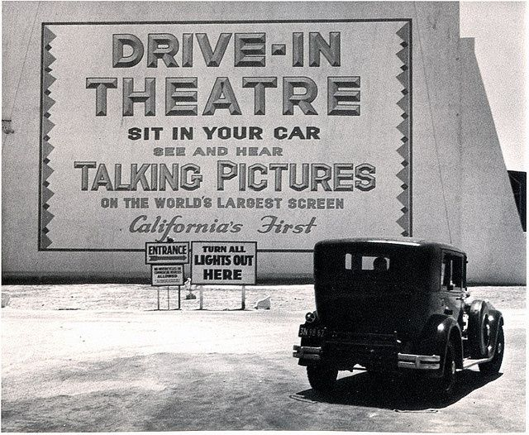

Minutes of the September 8, 2015 Meeting

2015

Sept. 13th. Wampsville NY 55th.^{t} Annual Car Show Mohican Model A Club. Large Flea Market www.mohicanmodela.org
Sept. 20th. Warren Center, PA CAR SHOW Cruise-In 11AM till ?? 9 th Annual Jeff Treadwell tread40@yahoo.com
- September 19, 2015 -- Worldwide International Model A Day 2015 Hosts: MAFCA/MARC -
Sept. 19-20 Troy, PA Heritage Festival 18 th. Annual www.paheritagefestival.org
Sept. 19st. Nichols, NY 5th Annual Car Show in Tioga Downs 9AM-4PM Reg. $15 shoffman@tiogadowns.com
Sept. 26th. Cayuta NY GLASS SHOP north of Alpine Junction on St Rt 13. 10-3 Registration $5 Benefit of Boy Scout Troop 50 Bring canned goods for food pantry and returnable bottles and cans for Scout Troop #50
Sept. 27^{tth.} Painted Post, NY GST BOCES Coopers Plains Campus 8th Annual Car Show 10-3 Rain or Shine
Reg. $7 by Sept. 21st.. Phone 607-654-2227 E-Mail jdekoeyer@gstboces.org
Oct 2 – 4 FALL CARLISLE
Oct 7-10 FALL HERSHEY

- Thanks to Ginny Bruckner and the Twin Tiers Vintage Car Club for this detailed schedule -

Sullivan Trail A’s Caravan to the Fillmore Glen Car Show 9-6-15
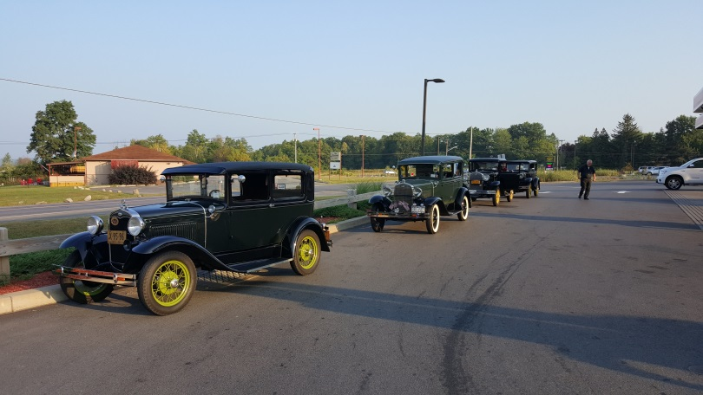
Jim, Monty, Gordon (Haag) and Taylor (Gordon’s girlfriend), Bill and Barb met at a convenience store in South Lansing before heading to the car show in the beautiful Fillmore Glen State Park in Moravia, NY.

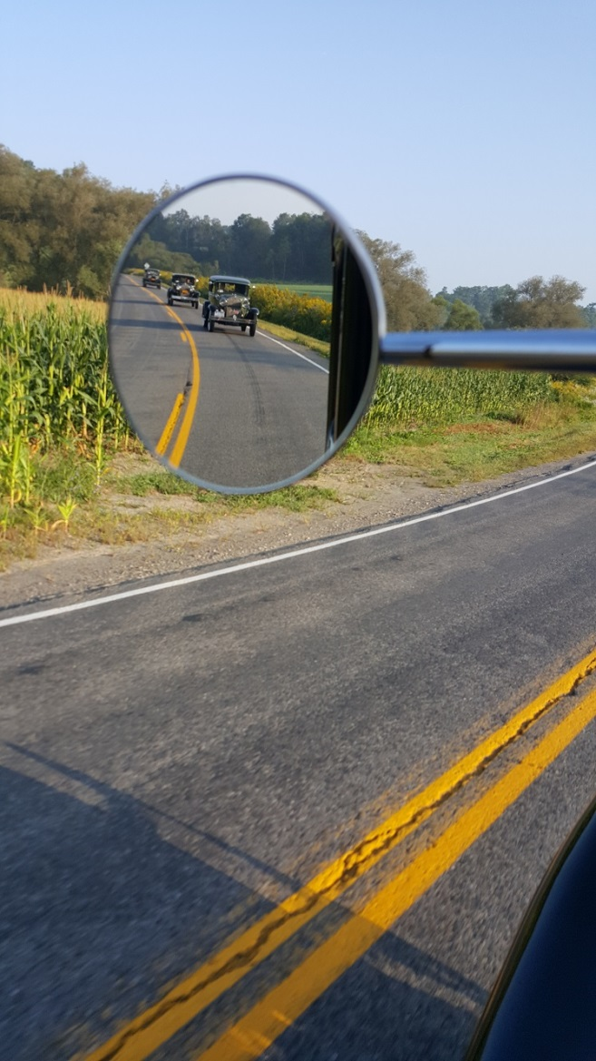
It was a gorgeous morning, nice and cool, as we gently drove through the countryside. Everyone in our four Model A caravan agreed that this morning drive was pleasant. Barb Haag had Bill stop Henry at one point so she could take a picture. She took a photo of the cars ahead; theirs was the last car in line. The photographer of the rear view mirror picture on the right, your President, almost lost his cell phone a couple times trying to take this photo while dangling his phone nearly out the window. This dare-devil behavior was more of a risk to his Model A than to the phone, questionable choice, eh? There’s an election coming up in November….

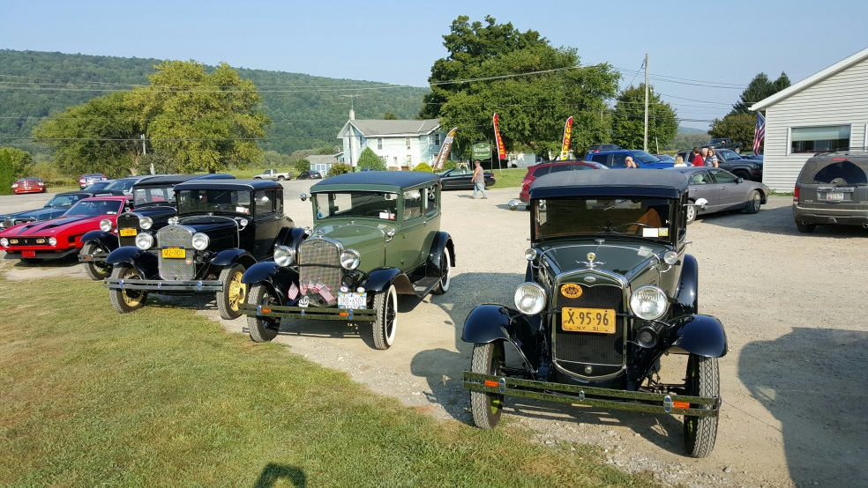
Every year we go to this show we stop at The Gathering Restaurant which is just a ½ mile south of the Fillmore Glen State Park. We have a nice breakfast, fun chat, and leave nice tips for the server who’s usually very busy on this car show day.

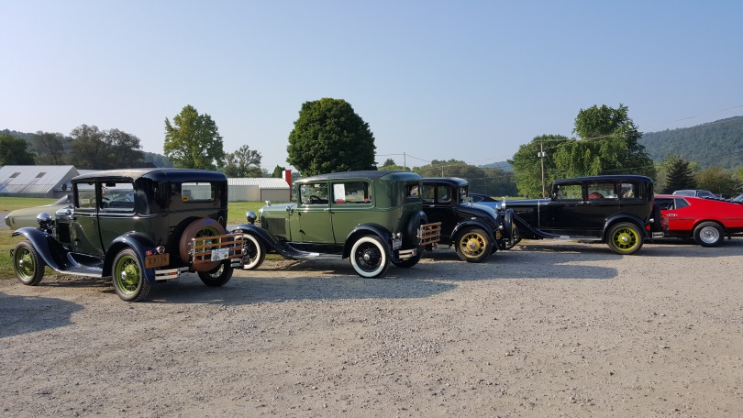
The Gathering Restaurant offers local certified organic eggs from Edwards Eggs with a choice of white, wheat, rye, Italian or buttermilk biscuit and homemade bread in white, wheat, rye, raisin or sourdough. Come with us next year!
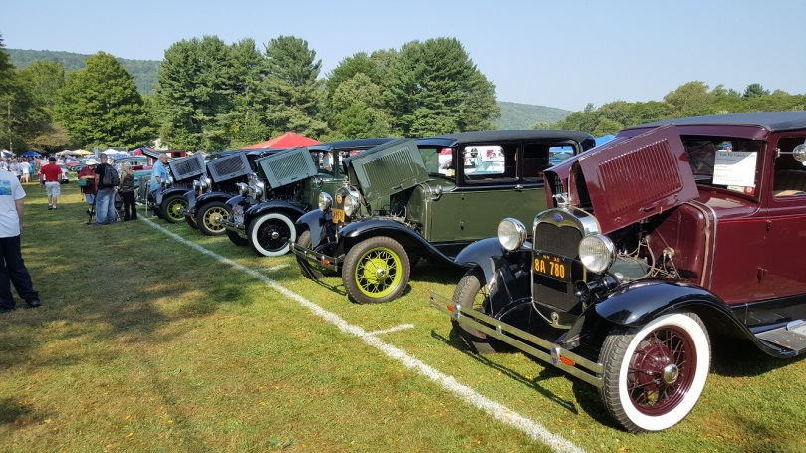
Here we were all lined up and proud to show off our A’s. All five Model A’s in the show were from the Sullivan Trail A’s MAFC, no other A’s were in the show. Maroon “A” is Jim Whittaker’s. Great job Sullivan Trail!

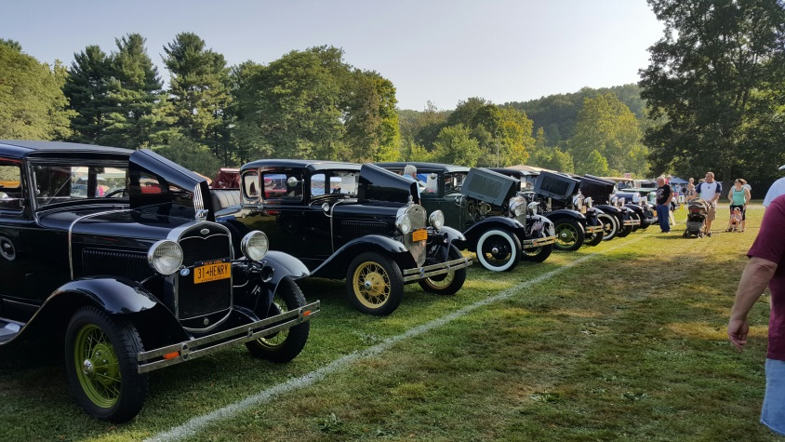
What a nice day it was. Hot, humid, hazy, upper 80s. Nice, really? Yep. Think of January/February 2016 and what those months will bring in 4 short months…..

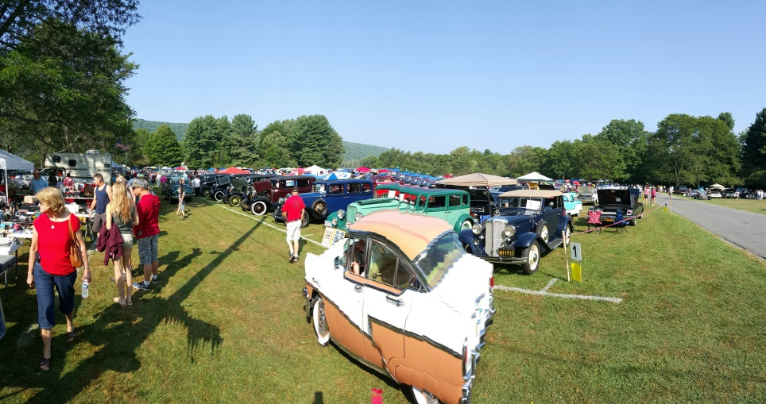
Here’s a panoramic photo view of the southeast corner of the show field. We’re lucky to be in Class #1 right in front of kind shade trees where we plop our chairs. Bruckner’s camper and vendor spot is on the left in front of the A’s.

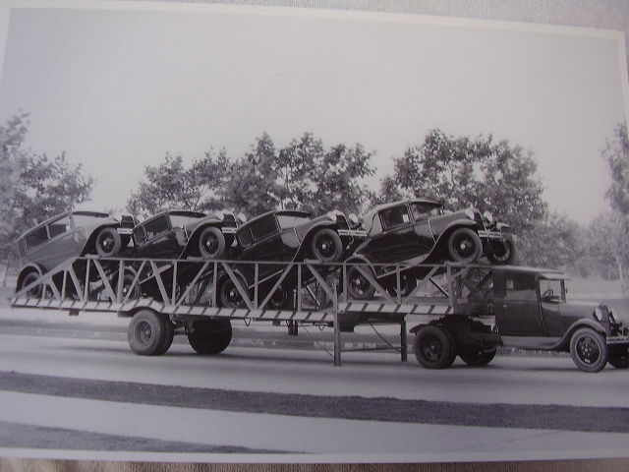

The Sullivan Trail A’s News

Did you know …

That MAFCA has a “Restorers Class?” I’ll bet you didn’t; take a look at this from the MAFCA web site:
MAFCA RECOGNITION AWARD FOR THE EVERDAY MODEL A
Background: The intent of The Restorers Class shall be to recognize MAFCA members who utilize their Model A Ford vehicle as a “driver” through its primary use of being enjoyed on today’s roads and highways. In consideration of today’s modern roads with faster highway speeds, vehicles require improved performance, reliability and safety. This class allows owners to operate their vehicles with original, era and aftermarket parts. While original parts are considered the “benchmark”, quality replacement parts and accessories with the look of the original part are acceptable. Improved or modern parts such as an overdrive, air conditioner or alternator are permitted but are not evaluated. The recognition is to encourage members to maintain their vehicles to a standard that reflects the original design and look, while permitting the owner to operate their vehicle with reliability, safety and comfort.
Policies & Procedures:  1. Vehicles are evaluated and awarded points based upon condition, finish and originality.  2. “Award Point System” - each Model A starts at zero points and has the potential to earn up to a maximum of 450 points.  3. Good era and reproduction parts are accepted; as identified they will receive one less point.  4. Evaluators do not test any equipment as to its proper operation.  5. Visual evaluation only carried out, no tools or measuring devices utilized.  6. Vehicle evaluation encompasses Engine, Body, Exterior Plating, Interior, Wheels/Tires and Undercarriage areas.  Entry Criteria:  1. Model A as defined by Ford production (benchmark) – No Modified or Speedster  2. Engine Block – Model A or B.  3. No fiberglass fenders or body parts.  4. Original or good reproduction parts as defined by Ford production for the year and model.  5. Paint: Model A color, correct for the year and model. Slight variations or interpretations are acceptable.  6. Vehicle must be licensed and road-worthy. | Permissible Items:  (No points awarded for these items)  1. Alternator  2. Radial Tires  3. Hydraulic Brakes  Accepted Items, not evaluated.  1. Turn Signals  2. Seat Belts  3. Additional Rear-View Mirror  4. Right Hand Tail Lamp and bracket.  5. Overdrive  6. 12 Volt System  7. Era Air Cleaner  8. Air Conditioner  9. Trailer Hitch  10. Accessories  11. Radios
Technical Tip: Model A Backfiring
Back firing is usually caused by the condenser failing or... the points may not have sufficient gap. Make sure they are set at .018 to .020”. Make sure they are not burnt. Backfiring can be caused by intermittent firing of the ignition system or very lean fuel mixture. If the car has been setting for a while, the carburetor float valve may be sticking. Clean the float valve good and set the float level. Backfiring due to intermittent ignition can be caused by a frayed wire on the bottom side of the distributor plate . . or .. by intermittent connection of the ignition switch.
Potential Solutions:
1) Check point setting first.
2) Replace condenser next (unless you are using modern points). Make sure the condenser you buy is the right length, some are too short, and that it is good quality.
3) Check that the carburetor float valve is operating correctly.
4) Sometimes the pop out type ignition switches get intermittent. As a last resort, replace the ignition switch/cable.
5) Check the GAV to make sure it is not set too lean
Source of this tip: Roy Cail, Tulsa Model A Ford Club

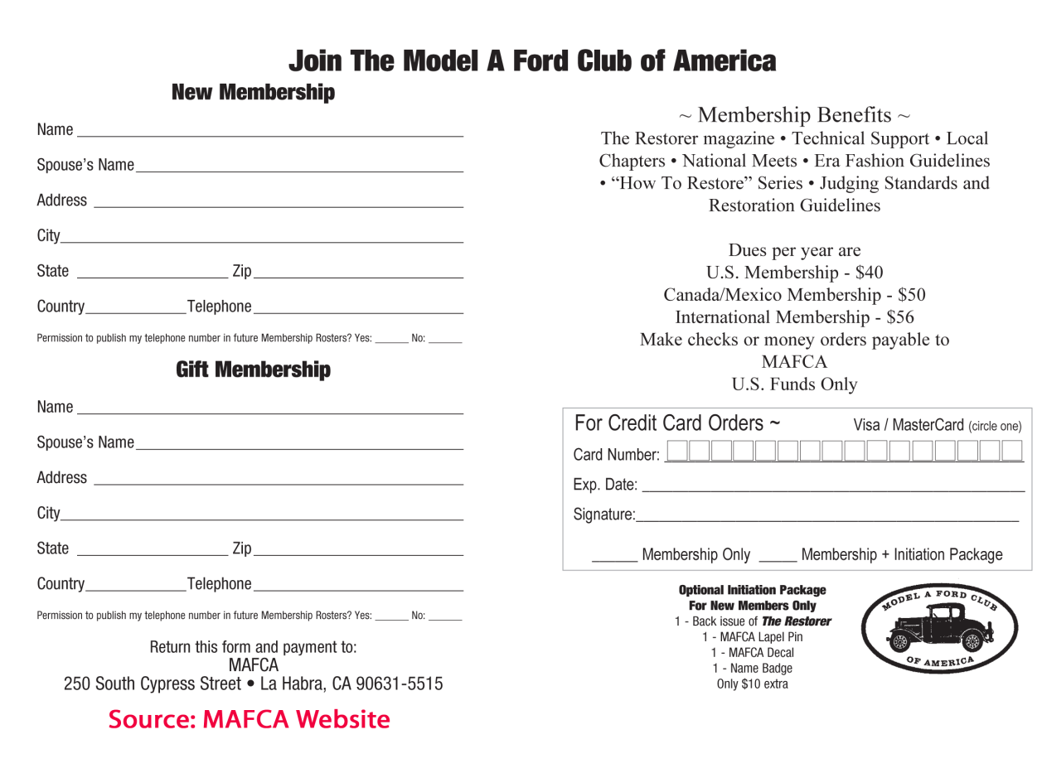
The Sullivan Trail A’s News

Did you know … this(?) about

