The Sullivan Trail A’s News

“Coming together is a beginning; keeping together is progress; working together is success.”
- Henry Ford
http://www.sullivantrailas.com 1903 1927–1931 October 2015

2008 4,849,340 Produced Volume 8 Issue 8

President

Jim Morris
jim.morris2831@aol.com

Vice President

Doug Archer

Treasurer

Mark Harth
bearfarm14818@gmailcom

Secretary

Beverly Harding
1stmafc@gmail.com

Director At Large

Bill Haag
fingers5n5@aol.com

Newsletter Editor
Jim Morris

Website Liaison

Jerry Wilcox

jerrywilcox55@gmail.com

Webmaster
Mike Horning
mhorningpsu@gmail.com
~~~~~~~~~~~~~~~~~~~~~~

Sullivan Trail A’s Meetings:
- Monthly
- 2nd Tuesday September - June
- 7pm
- United Methodist Church
1034 W Broad St
Horseheads, NY

In This Issue
- From The President’s Garage
- 10-13-15 Meeting Minutes
- Upcoming Events
- Hammondsport Tour Photos
- Did you know …?
- Technical Tip: Knock Knock!
- MAFCA Membership

FROM THE PRESIDENT’S GARAGE
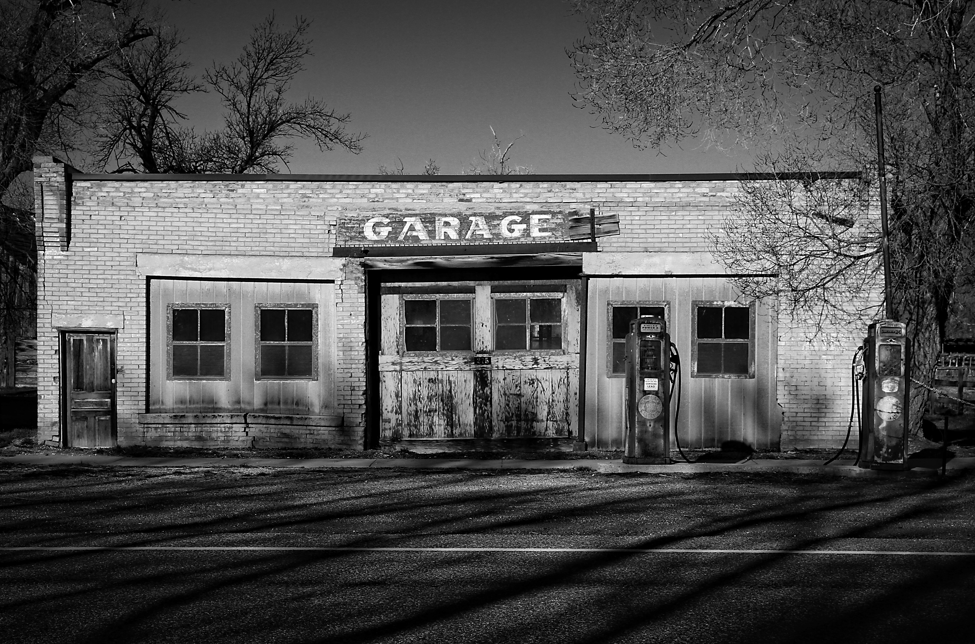

Days before our October meeting Bob Harter passed away. He had been battling illness for many months. Bob was a key player in finding a perfect meeting place for our Club meetings, the United Methodist Church in Horseheads, and Karen has always been at meetings lending a big hand with refreshments. Bob’s humor, generosity, broad smile, and good will were always appreciated.. he will be missed. Our deepest condolences are sent to Karen and family.
All for now, Jim

Minutes of the October 13, 2015 Meeting
Meeting was called to order by President Jim Morris at 7PM. Thirteen members and two new members were present. Welcome to Gordon Haag and Taylor Lance.
- Motion to approve Secretary’s report by Jerry, 2nd by Don. Motion carried.
- Treasurer reported the fund balance. Motion to approve by Monty, 2nd by Dave. Motion carried.
- Remarks by several members about deceased member Bob Harter. He was a good friend to many and a valued member of STMAFC.
- A discussion was held regarding purchasing bricks at the MAFFI museum to honor deceased members. A motion to amend the by-laws was made by Larry, 2nd by Jerry. Motion carried. The following amendment will added to the by-laws effective October 13, 2015: “Funds permitting, a MAFFI Museum memorial brick will be purchased to honor deceased members.”
- Ginny related information about the tour on the 17th. Members will meet at the Jubliee on Westinghouse Rd in Horseheads and leave at 9AM. Arrive at the Finger Lakes Boating Museum about 11:00AM. Admission at the museum is $6.00. Arrive at The Park Inn and Restaurant about 12:30PM for lunch. Arrive at the Glenn Curtiss Museum about 1:15PM. Admission to museum is $7.00.
- Bruce gave information about safe group touring and some of the dangers to be aware of.
- Larry has a 1930 Sport Coupe for sale. If interested, call Larry at 607-594-2458.
- Bill will locate a venue for the Dec 8th club Christmas party. He will report at the Nov meeting.
- Next month will be elections for club officers. If you would like to run for any office, please let the members know at the Nov meeting.
- Thank you Monty for the delicious refreshments. Jerry will provide refreshments for the Nov meeting.
- The 50/50 raffle was won by Jerry.
Respectfully submitted,
Bev Harding, Secretary.

2015
- Not many events left for 2015!
- How about one or two weekend breakfast runs as we’ve done in years past? Chef’s Diner just south of Watkins Glen is convenient for most of us, Denny’s is also possible. We have a meeting on November 10th when we could discuss this, but we have so few weekends before bad weather becomes limiting maybe we can arrange a breakfast run before the meeting. Please let me know ASAP if you have thoughts on this and I’ll work on getting the word out via email!
- Christmas meeting/dinner will be coming up in early December, will keep you posted, details to follow in the next newsletter and we’ll discuss at the next meeting on November 10th. Bill Haag is working on location and related details.
- December 3,4,5 -- Medford Oregon, MAFCA 2015 National Awards Banquet
Hosts: Rogue Valley A's / Henry's Lady Chapter / Sis-Q A's
- The MARC 2016 National Tour will be held in Newburgh, NY from September 19 to September 22. Save the date! More information to follow when MARC sends it out.

Hammondsport Tour

Saturday October 17, 2015
Many thanks to Ginny Bruckner for her fine work planning & coordinating this tour!!

Jim & Julie On way to Finger Lakes Boating Museum

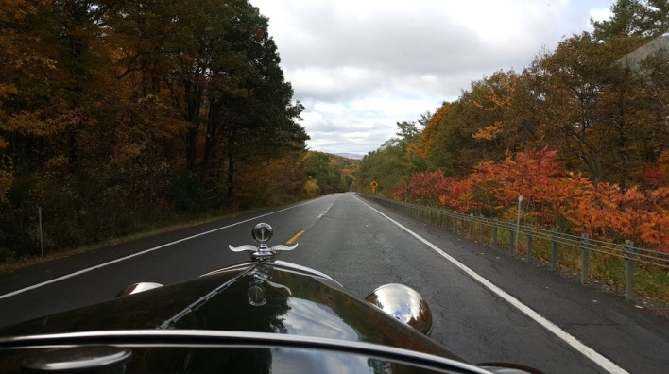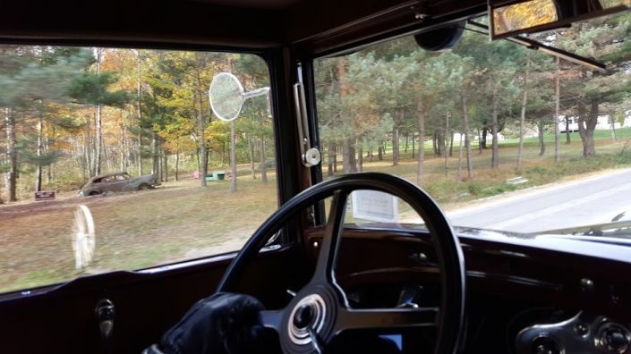

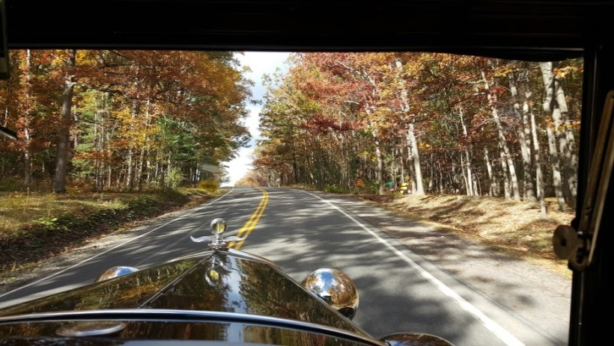

Wow! Joining rest of gang on the road, getting gas, arrival at Museum
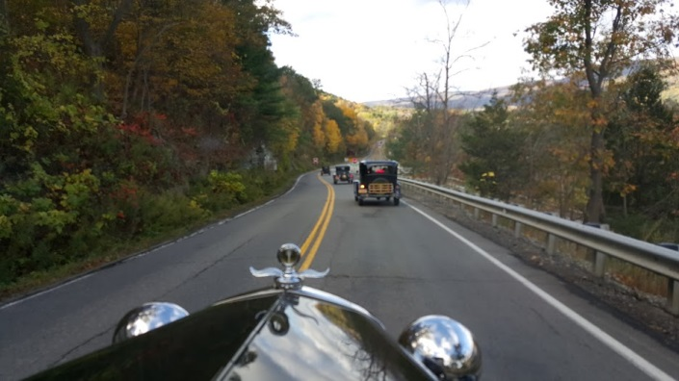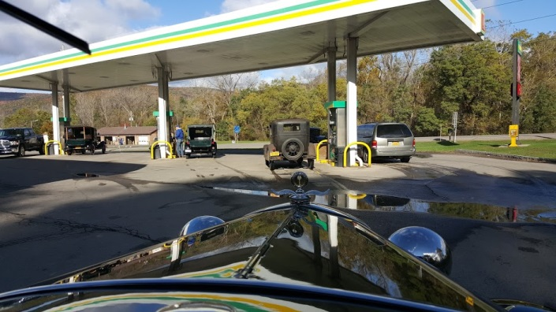

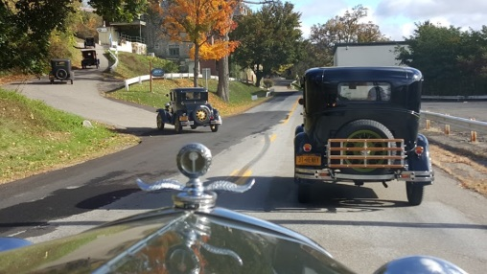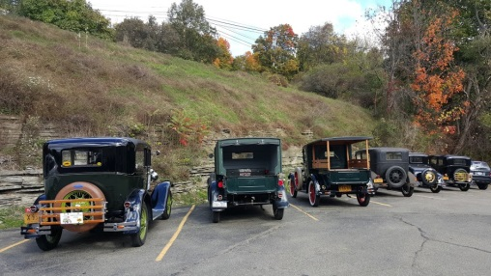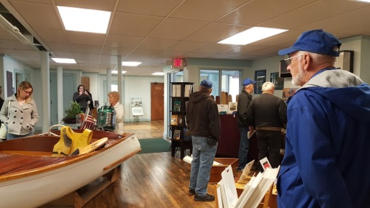
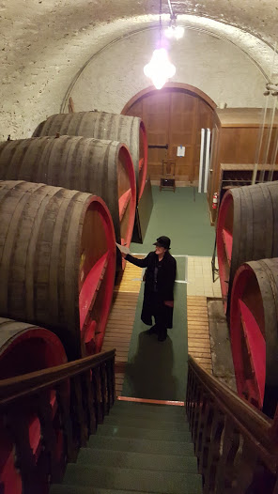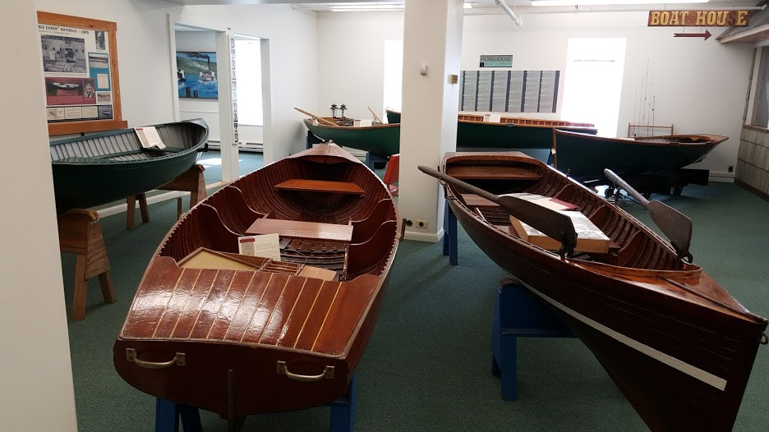

Lunch at the Park Hotel in Hammondsport, great lunch, and many smiles from onlookers at the parade of A’s

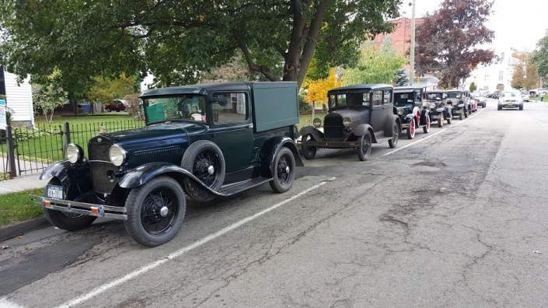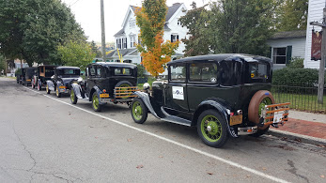

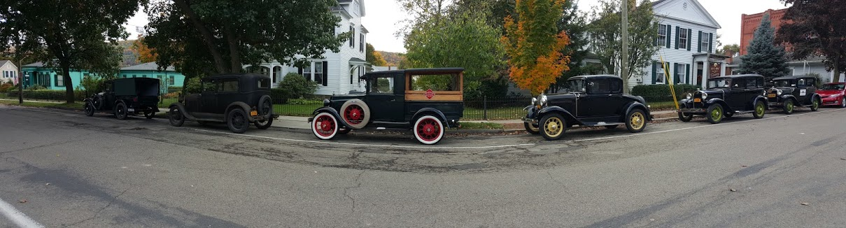

Last Destination: The Glen Curtiss Museum

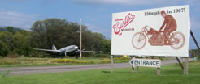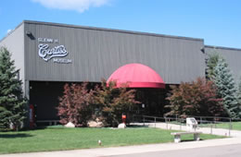

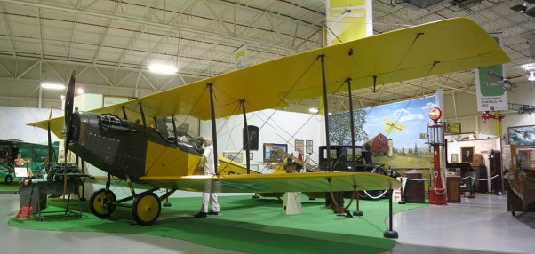

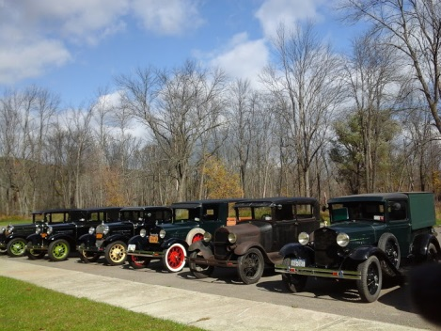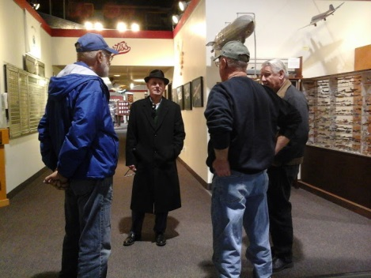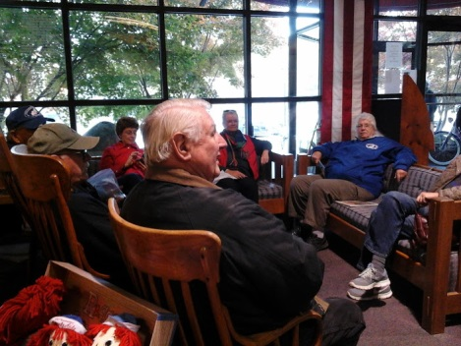

Great Weather, Great fun, Great Company!

The Sullivan Trail A’s News

Did you know …

… that there is an answer to the question: Do I need a thermostat on my Model A?

That is a question that has been kicked around the garage for some time now. The early thoughts were that a thermostat was needed to slow the water flow in the radiator. Extensive tests have shown that changes in the rate of water flow through the radiator results in negligible change in water temperature. A Model A radiator should cool the engine under normal driving conditions.
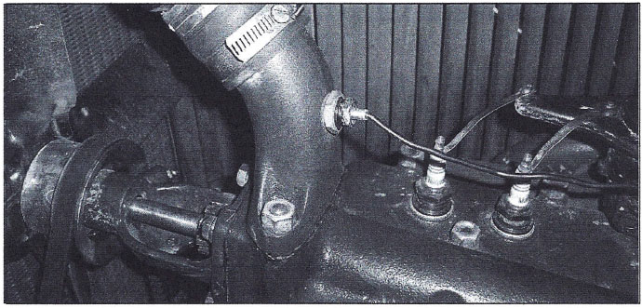

A good clean radiator, even a stock one, should keep the engine operating at a normal level (160 -170 degrees). If your engine is running hot you should look at all of the things that could cause that to occur. An older radiator, one that appears in good shape and flows well, may have deteriorating connections of the fins to the tubes, which reduces its ability to transfer heat to the surrounding air and is usually the cause of engines running hot.

The original design of the Model A radiator is for a Thermo-Syphon system used in conjunction with a water pump. The entire cooling system was engineered to use the best of both types of systems. The thermo-syphon system keeps the coolant in place until the engine reaches an operating temperature of around 180 degrees. The pump increases the flow of coolant when the engine is operating at higher speeds and the thermo-syphon system would not move the coolant fast enough to cool the engine. So the Model A was equipped to have a thermostat of sorts with the thermo-syphon system helping the engine warm up before the coolant started moving.

This still doesn’t answer the question regarding installing a new thermostat. The modern fuel of today requires the engine to operate at above 160 degrees to burn clean and with the most efficiency.

Tests were made using a new reproduction radiator along with a high compression head. The Motometer temperature gage (thermometer) on the radiator cap takes it’s readings through a special stud, mounted in Motormeter. Through many operating conditions, the thermometer never rose to the operating range on the Motometer. A modern temperature gage with degree readings was then installed along with a temperature sensor mounted in the upper water outlet neck. After running the Model A through many operating conditions it was surprising to find that the newly installed temperature gauge never rose above 140 degrees on a hot summer outing.

After seeing the engine operating so cold, a 160-degree thermostat was installed in the upper radiator hose. In a short period of time the engine water temperature now rises to 160degrees F as seen on the Water Temperature Gauge. The opening and closing of the thermostat can be seen on the temperature gauge as the indicated temperature rises to 170° and then drops to 160° as the thermostat opens and closes.

Installing a thermostat will allow the engine to operate at the most efficient temperature range, getting the most out of the fuel that is being used and at the prices we are being forced to pay you best get the most out of your money.

This is an easy and beneficial improvement that will make your Model A operate at an efficient temperature level, allowing complete and proper burning of the fuel, thereby reducing unburned fuel and fuel contaminates that produce carbon buildup Water Temp Gauge and sludge in the engine. The illustrated thermostat can be purchased from any Model A Parts Supplier in temperature ranges of 160° or 180°F operation. Installing a water temperature sensor in the upper water outlet neck and a water temperature gauge, will provide a more accurate indication of your engines operating temperature.

Thanks to the Tulsa Model A Ford Club for this information.

For more information, go here:

http://www.tulsamodelafordclub.com/do-i-need-a-thermostat-on-my-model-a/

Technical Tip: Knock Knock!
Do you have one of those wandering knocks in the old four banger? Here is a way to check and see if a loose timing gear is causing the knock.
With the engine idling, insert the timing pin into the gear cover opening as if you were timing the car. Be careful of that turning fan!! Press in firmly on the pin; if the knock stops, the trouble is undoubtedly a loose timing gear. If the knock doesn’t stop ------.
Source: Modesto Area A’s http://www.modestoareamodelaclub.org/knock-knock/

