The Sullivan Trail A’s News

“Coming together is a beginning; keeping together is progress; working together is success.”
- Henry Ford
http://www.sullivantrailas.com 1903 1927–1931 December 2015

2008 4,849,340 Produced Volume 8 Issue 10

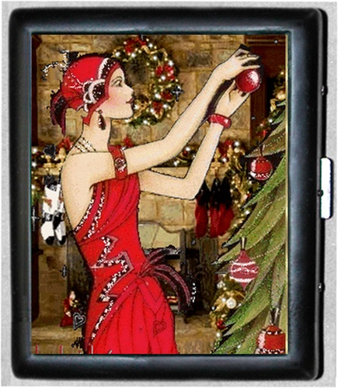
Merry Christmas
And
Happy New Year!

President

Jim Morris
jim.morris2831@aol.com

Vice President

Don Bushart

dbjb806@icloud.com

Treasurer

Mark Harth
bearfarm14818@gmailcom

Secretary

Beverly Harding
1stmafc@gmail.com

Director At Large

Bill Haag
fingers5n5@aol.com

Newsletter Editor
Jim Morris

Website Liaison

Jerry Wilcox

jerrywilcox55@gmail.com

Webmaster
Mike Horning
mhorningpsu@gmail.com
~~~~~~~~~~~~~~~~~~~~~~

Sullivan Trail A’s Meetings:
- Monthly
- 2nd Tuesday September - June
- 7pm
- United Methodist Church
1034 W Broad St
Horseheads, NY

In This Issue
- From The President’s Garage
- Upcoming Events
- Christmas Dinner Photos
- Did you know …?
- Technical Tip: Head Stud #8
- MAFCA/MARC Membership

FROM THE PRESIDENT’S GARAGE
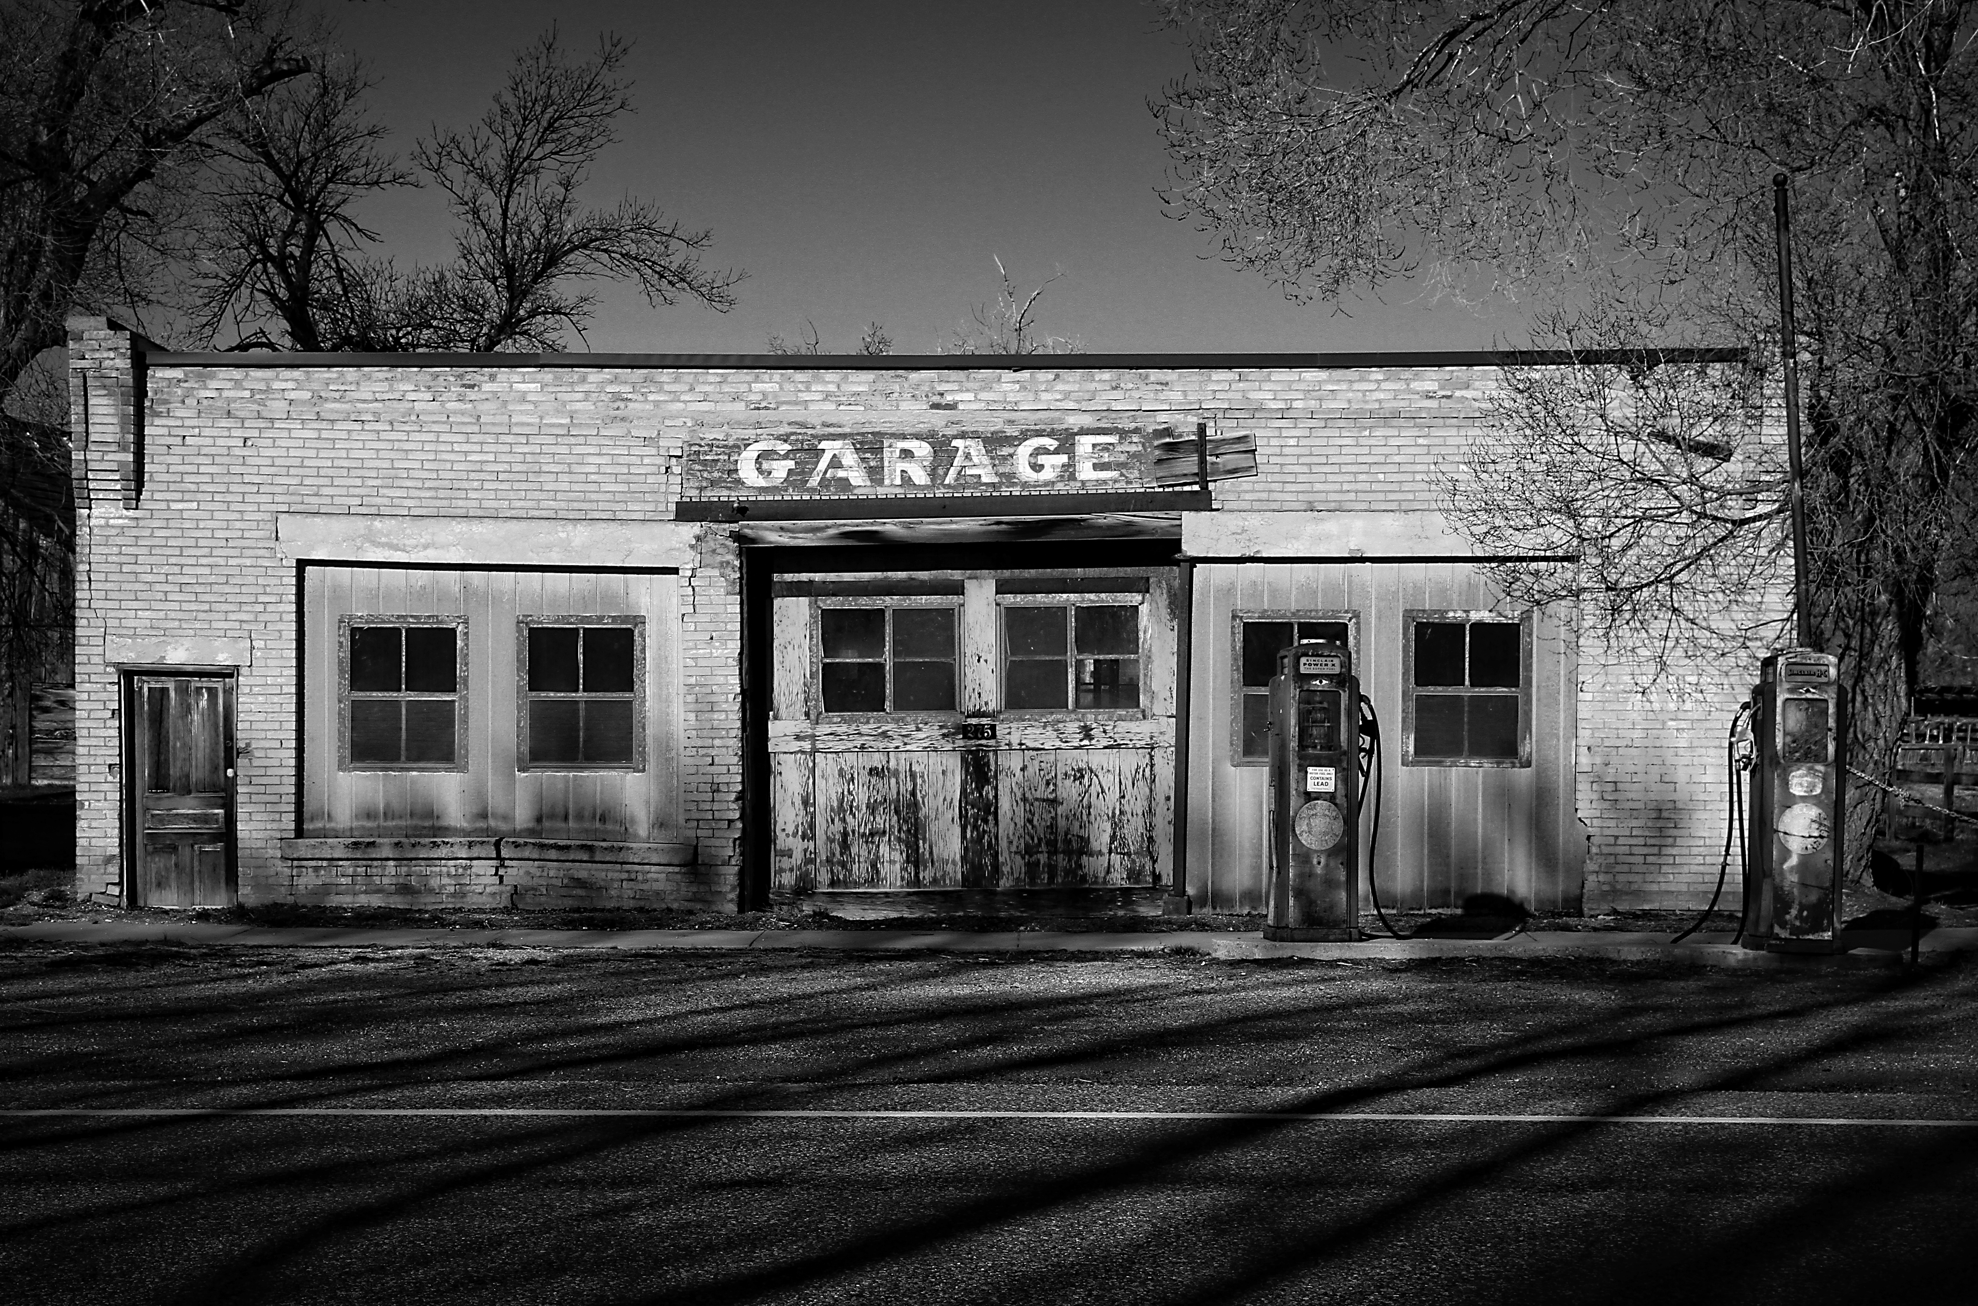

Our annual Christmas dinner was held at the Old Country Buffet on December 8th when we usually have our monthly business meeting and I for one witnessed much good cheer as we closed out another year as a very active Model A Ford Club. The gift-giving game was full of laughter and surprises, many thanks to Bill Haag for once again executing the role of Santa in fine fashion and good humor!

Be well everyone and enjoy end of the year festivities, drive safely, and see you all after the New Year.
All for now, Jim

Meeting Minutes will continue in the next Newsletter, no formal meeting was held in December.

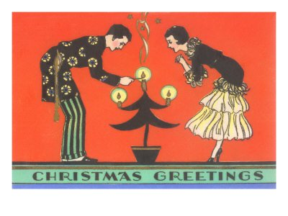

2016
-Full calendar will appear in January 2016 Newsletter-

- June 19 - 24, 2016 -- Loveland, Colorado, 2016 MAFCA National Convention
Hosts: Model A Ford Club of Colorado

The Model A Ford Club of Colorado invites you to join us in Loveland, Colorado for the 2016 MAFCA National Convention. Come and enjoy the cool crisp air of the Rocky Mountain State.
Registration materials and full descriptions of events and activities will be published in the Jan-Feb 2016 issue of the Restorer magazine and also available for download from our website.
Please go to our web-site for the latest information. Enjoy the videos as a sample of what you'll see in this area. A complete list of nearby accommodations is there for your selection. We look forward to seeing and meeting you this coming June.
Web Site: http://www.milehighcountry2016.org/

- September 19 - 22, 2016 -- Newburgh, NY 2016 MARC National Tour
Hosts: Hudson Valley MAFC
Web site: http://hudsonvalleymarc.org/

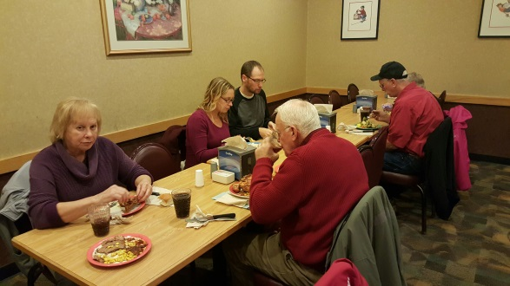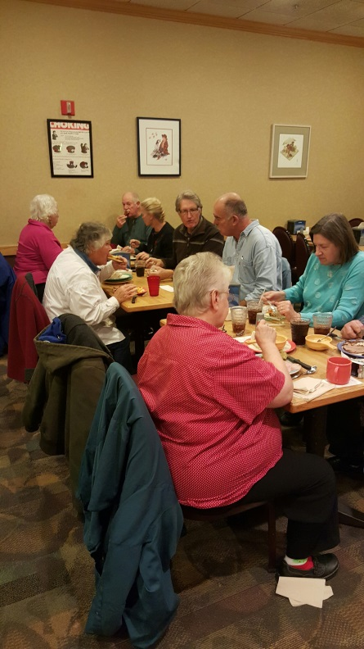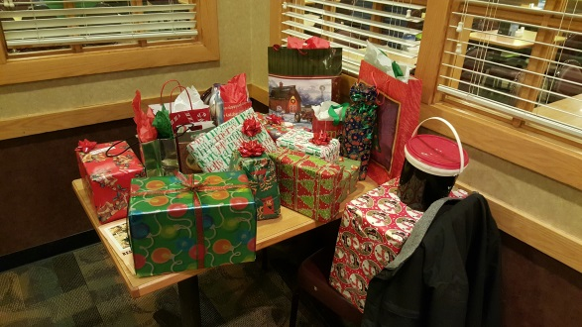
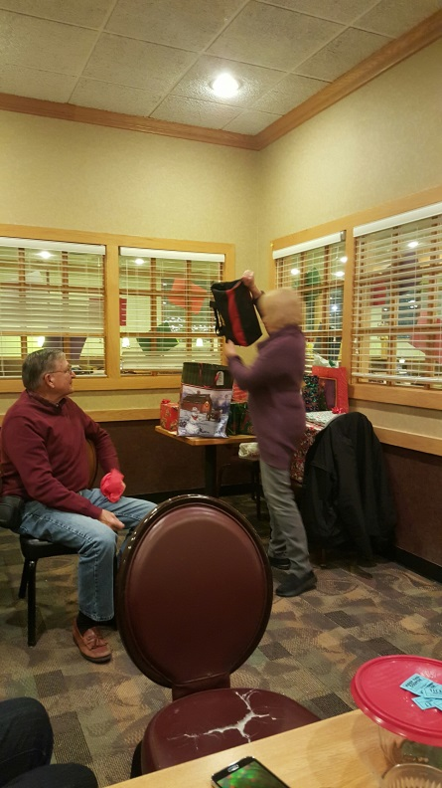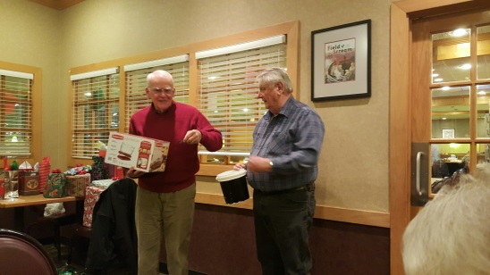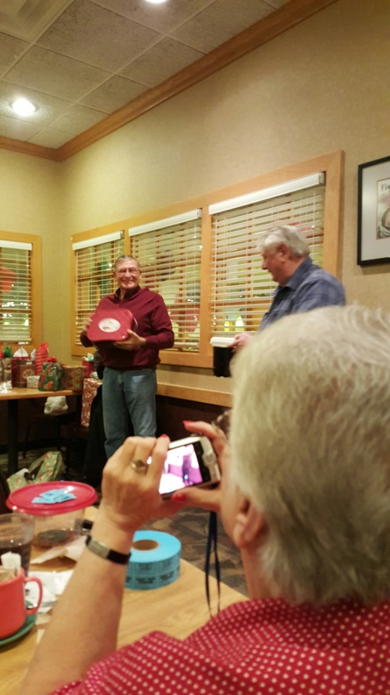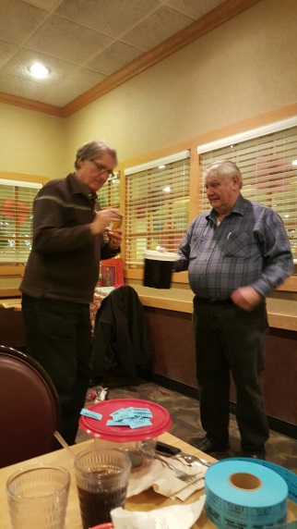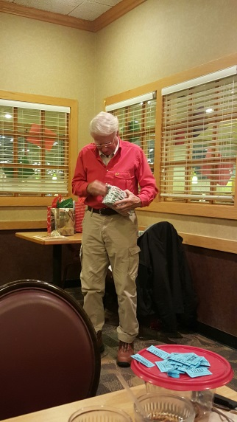

The Sullivan Trail A’s News

Did you know … this about head stud #8?

Source: Orange County MAFC and Tom Endy http://www.ocmafc.org/techarticles/Tom%20Endy%27s%20Special%20Topics/Number%20Eight.pdf

Technical Tip: Complete Lube Job?
You did a COMPLETE lube job? How about the starter crank hole? It needs a few squirts of oil every 500 miles, says Henry. There is a small hole inside the crank hole. It is hard to see. The oil leaks down to the front spring. The hole may need to be cleaned out with a piece of wire before oiling. I bet you didn't know that!
Source: River Cities MAFC, Georgia
http://www.rivercitiesrunningboard.com/techtips.php

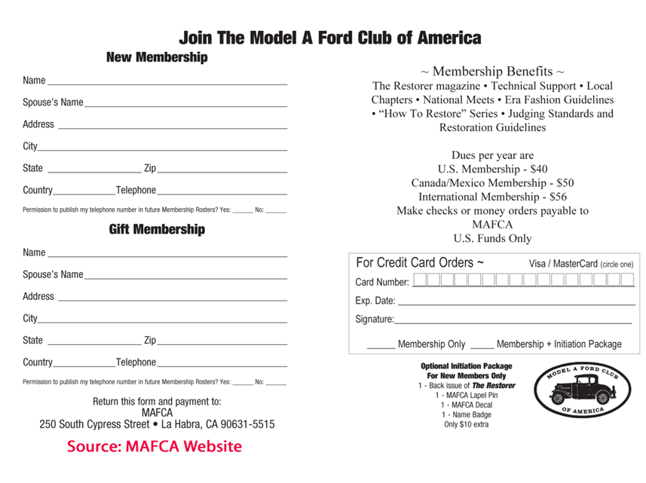

MODEL “A” RESTORERS CLUB
6721 Merriman Rd
Garden City MI 48135
(734) 427-9050 office
(734) 427-9054 fax
modelarestorers@sbcglobal.net

Membership Application

2016 Dues- New or Renewals ( ) US Membership $45.00
( ) US Air Mail $57.00 ( ) Canada $55.00 ( ) International $61.00

New Members Only- Partial Membership: J/A, S/O & N/D issues only!
( ) US Membership $24.00 ( ) US & Canada Air Mail $34.00 ( ) International $42.00

IMPORTANT:
Make checks payable to Model “A” Restorers Club (M.A.R.C.)

All Memberships from outside the U.S. are to be remitted by International Money Orders in U.S. Funds (drawn on U.S. Bank) or credit card. And a personal check drawn on U.S. bank (U.S. funds must stamped on check.)

CREDIT CARD INFORMATION:
( ) Visa ( ) Master Charge ( ) Discover Credit Card ( ) American Express #______________________________________

EXP Date_____ CVV2 Code #_________ Phone # ____________________________
(Last 3 numbers on back of Credit Card)

Membership #___________________ E-mail________________________
Name: __________________________________________________
Address: ________________________________________________
City: ______________________ State: ___________ Zip: _________
I give permission to publish my phone number in the future MARC Membership Rosters:
( ) Yes ( ) No Phone: _________________________
I give permission to publish my email in the future MARC Membership Rosters:
( ) Yes ( ) No Email: _________________________

With your membership you will receive a club membership I.D. card and the Model “A” News, our BI-monthly club magazine. In addition, each member is entitled to a free 40 word classified ad in each issue of our international publication, the Model “A” News
(A good source of parts and information you may need for your car).

