The Sullivan Trail A’s News

“Coming together is a beginning; keeping together is progress; working together is success.”
- Henry Ford
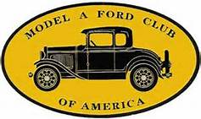 http://www.sullivantrailas.com 1903 1927–1931 May 2015

2008 4,849,340 Produced Volume 8 Issue 5

President

Jim Morris
jim.morris2831@aol.com

Vice President

Doug Archer

Treasurer

Mark Harth
bearfarm14818@gmailcom

Secretary

Beverly Harding
1stmafc@gmail.com

Director At Large

Bill Haag
fingers5n5@aol.com

Newsletter Editor
Jim Morris

Website Liaison

Jerry Wilcox

jerrywilcox55@gmail.com

Webmaster
Mike Horning
mhorningpsu@gmail.com
~~~~~~~~~~~~~~~~~~~~~~

Sullivan Trail A’s Meetings:
- Monthly
- 2nd Tuesday September - June
- 7pm
- United Methodist Church
1034 W Broad St
Horseheads, NY

Oct. 1, 1908: Ford introduces the Model T, which became one of the most popular cars in the world. Production officially ended in May 1927 after total world production of 15,458,781.
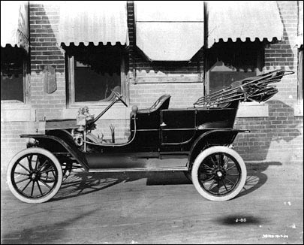

In This Issue
- From The President’s Garage
- 5-12-15 Meeting Minutes
- Upcoming Events
- Saturday Evening Post Covers 1929
- Did you know …?
- Technical Tips
- MAFCA Membership

FROM THE PRESIDENT’S GARAGE

I’ve become a blogger. Yep. Know what blogging is? Well, it’s not logging or flogging or dogging or hogging. That help? Probably not. Okay, blogging is this .. “… the act of posting content on a blog (a Web log or online journal) or posting comments on someone else's blog.” That better? Probably not. This isn’t funny, eh? Okay, serious. A blog is like a diary written so it can be viewed on the Internet by anyone who lands on the blog (diary) page. Why do I mention this? Why have I become a blogger? Well, a bunch of us are headed for the Maine Lobsters and Lighthouses Tour sponsored by MAFCA and hosted by the Model A Club of Maine so I’ve created a blog so those of you at home can check into the blog to read about our daily adventures. The best way to find the blog is to go to the MAFCA web site (http://www.mafca.com/) and on the home page look for this and click on “Follow Jim’s blog here”:

2015 National Tour
May 13 - The first of several members to blog their experiences on this tour is former MAFCA director Jim Morris. Follow Jim's blog here.
Hopefully I’ll be able to update the blog daily about activities and include photos of where I and Julie are, where Don Bushart is, where Sam and Mary Ann LaLomia are, and where Doug and Bea Archer are. The blog has been started so take a look!
All for now, Jim

Minutes of the May 12, 2015 Meeting
Meeting was called to order at 7PM by President Jim Morris. Twelve members and new member Rich Phillips were present.
- Motion to approve Secretary’s report by Don, second by Bruce. Motion carried.
- Treasurer reported a balance of $716.27. Motion to approve Treasurer’s report by Bruce, second by Ginny. Motion carried.
- A picnic in June in lieu of meeting was discussed. It was decided to hold the picnic on the 16th instead of the 9th to accommodate the members who will be touring on the Lobsters and Lighthouse Tour in Maine. Motion to have club purchase a meat platter by Bill, second by Don. Motion carried. Bev will order the meat platter. A list of those attending was passed around and the dishes they will bring. Notice will be placed in newsletter regarding date and time of picnic.
- Ginny brought information regarding the Living History Center in Cortland. There are 3 museums close to each other and this is a possible location for IMAFD on Sept 19. There will be more discussion at Sept meeting.
- A picnic at Harris Hill was discussed for July 25th. Don will check into the soaring schedule.
- Lunch in Owego before the MAFCA tour in June was discussed. Jim is going to try to set it up for May 30th. Jim is going to set up a blog of the upcoming tour with Julie (his intrepid copilot) and Henrietta to document the tour. We look forward to many pictures and a daily log about the tour.
- Ginny provided the delicious refreshments – THANKS! Bill volunteered Barb to provide the refreshments for Sept meeting.
- Larry won $14.50 in the 50/50 raffle.
- Motion to adjourn at 7:50PM by Larry, second by Don. Motion carried.

Respectfully submitted,
Bev Harding, Secretary

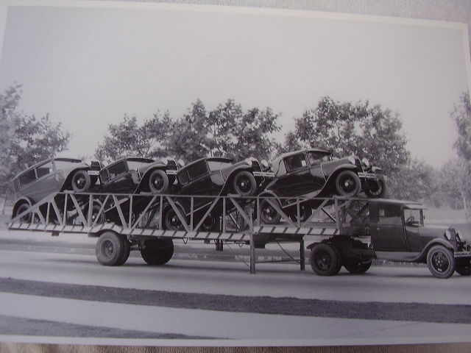

2015
- Tuesday June 16, 2015 at 6:00 PM Sullivan Trail A’s dish-t0-pass picnic at the United Methodist Church, 1034 West Broad Street, Horseheads NY. No business meeting on Tuesday June 9th.
- June 7-12, 2015 -- 2015 MAFCA National Tour - Lobsters and Lighthouses of Maine
Kennebunkport, Maine to Bar Harbor, Maine
Hosts: Pine Tree A’s
- June 21 -26 – MARC National Meet
French Lick, IN; hosted by the National Meet Region.
- September 19, 2015 -- Worldwide International Model A Day 2015
Hosts: MAFCA/MARC

Saturday Evening Post covers 1929
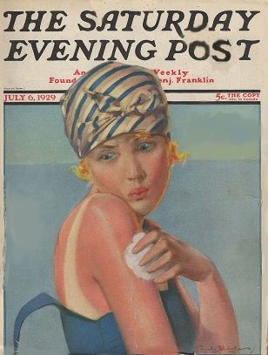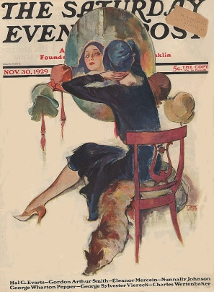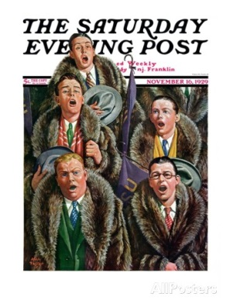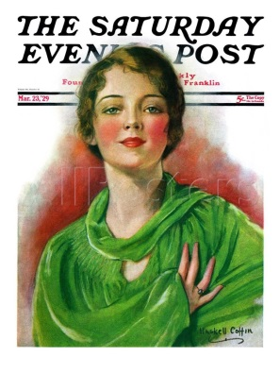

The Sullivan Trail A’s News

Did you know …

… this about Clara and Henry Ford?
On April 11, 1888, 24-year-old Henry Ford married Clara Jane Bryant on her 22nd birthday at her parent’s home in Greenfield Township, Michigan. Clara Ford would prove to be a big supporter of her husband’s business ideas: Fifty years later, Henry Ford, who by then had founded the Ford Motor Company, invented the top-selling Model T car and revolutionized the auto industry with his mass-production technology–was quoted in a 1938 New York Times Magazine article as saying, “The greatest day of my life is when I married Mrs. Ford.”
The couple, both of whom came from farm families, first met at a New Year’s dance in Michigan in 1885. During their courtship, they enjoyed such activities as dancing, corn-husking parties and boating excursions. According to “Clara: Mrs. Henry Ford,” a biography by Ford R. Bryan: “The two were impressed by each other, Clara with Henry’s unique mechanical talents and Henry with Clara’s serious and appreciative disposition.” They were engaged in April 1886, but the future bride’s mother thought she was too young to wed and made them wait another two years.
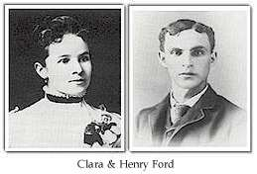
After their marriage, the Fords lived on farm land given to Henry by his father. By 1891, however, the couple moved to Detroit, where Henry Ford began working as an engineer for Edison Illuminating Company. The couple’s only child, Edsel, was born in November 1893. In 1896, Ford completed a four-wheel, self-propelled vehicle with a gasoline engine called the Quadricycle. During the early years of their marriage, the couple lived in 10 different rental homes while Henry worked to develop an automobile. After incorporating the Ford Motor Company in 1903, Henry launched the Model T in 1908. The car, which was in production until 1927, held the record for the world’s top-selling vehicle until it was surpassed by the Volkswagen Beetle in 1972.
In 1915, the Fords moved into a mansion built on land they owned in Dearborn, Michigan. The home, named Fair Lane, included an indoor swimming pool, billiard room, bowling alley and dance floor, as the Fords had always liked to dance. Clara Ford managed the estate staff, pursued such interests as gardening and traveled around the world on business trips with Henry.
Henry Ford died at the age of 83 on April 7, 1947; Clara Ford died three years later, on September 29, 1950, at the age of 84. Their son Edsel, who worked for the family business, preceded both his parents in death, dying at the age of 49 from cancer on May 26, 1943.
Adapted from: http://www.history.com/this-day-in-history/henry-ford-marries

Technical Tip: The condition of the condenser
A simple way of checking the condition of the condenser is to remove the distributor cap, body, and rotor. Make sure the points are closed. Turn the ignition on and place the high tension lead (from the coil) about 1/2 inch from any convenient ground on the engine. Push points open with a screwdriver then close them. The resulting spark should jump the gap with a sharp snap and a straight line and have a blue tinge. If the condenser is weak the spark will still jump the gap, but will be stringy and white in color. If so replace with one that passes the first test. - Ralph Workman

Thanks to: Poco Quatros Model A Ford Club

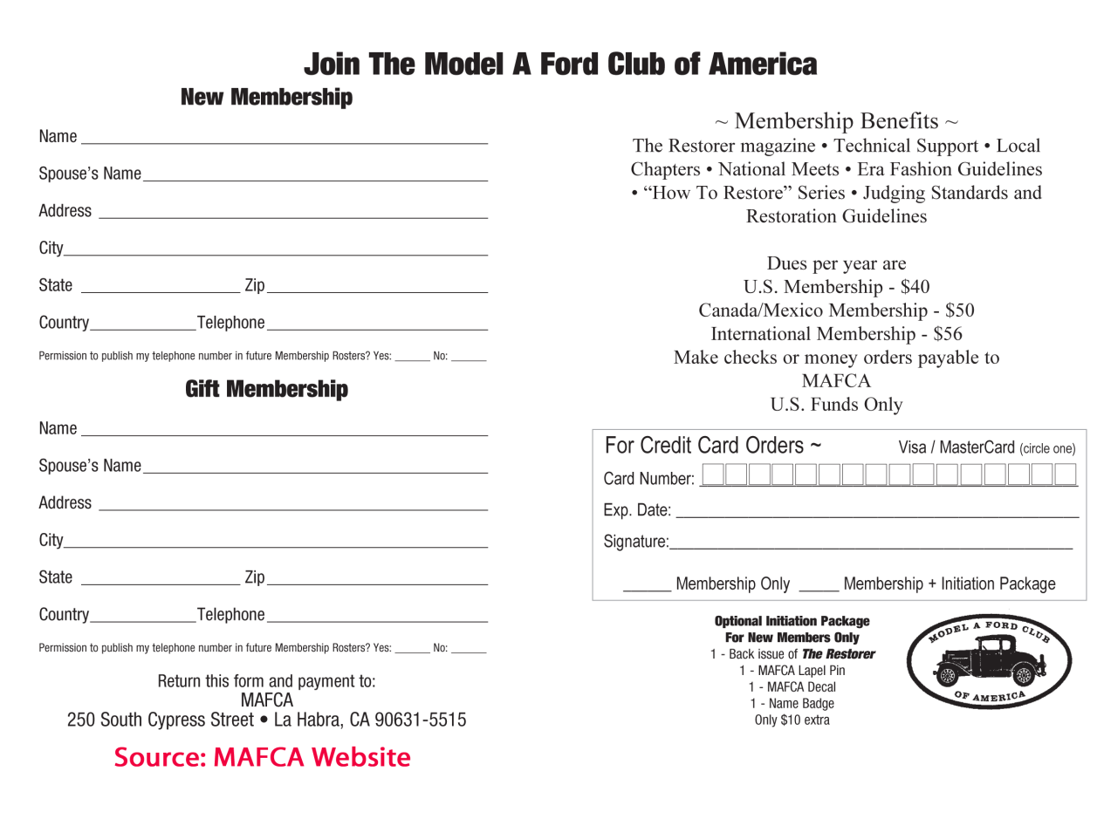
The Sullivan Trail A’s News

Did you know … this(?) about

