The Sullivan Trail A’s News

“Coming together is a beginning; keeping together is progress; working together is success.”
- Henry Ford
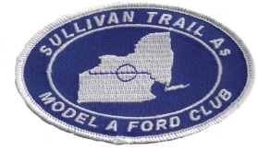 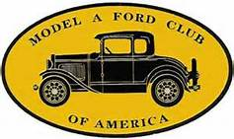 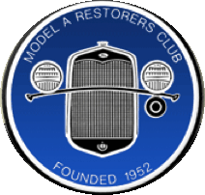 http://www.sullivantrailas.com 1903 1927–1931 June 2015

2008 4,849,340 Produced Volume 8 Issue 6

President

Jim Morris
jim.morris2831@aol.com

Vice President

Doug Archer

Treasurer

Mark Harth
bearfarm14818@gmailcom

Secretary

Beverly Harding
1stmafc@gmail.com

Director At Large

Bill Haag
fingers5n5@aol.com

Newsletter Editor
Jim Morris

Website Liaison

Jerry Wilcox

jerrywilcox55@gmail.com

Webmaster
Mike Horning
mhorningpsu@gmail.com
~~~~~~~~~~~~~~~~~~~~~~

Sullivan Trail A’s Meetings:
- Monthly
- 2nd Tuesday September - June
- 7pm
- United Methodist Church
1034 W Broad St
Horseheads, NY

- We’re off for the summer!
- Next meeting is Tuesday
September 8, 2015
- Abbreviated Newsletter!
- Enjoy a safe, memorable, fun summer everyone!

In This Issue
- From The President’s Garage
- 6-16-15 Picnic Report
- Upcoming Events
- Photos & Video Links Lobsters and Lighthouses Tour
- Did you know …?
- Technical Tips
- MAFCA Membership

FROM THE PRESIDENT’S GARAGE
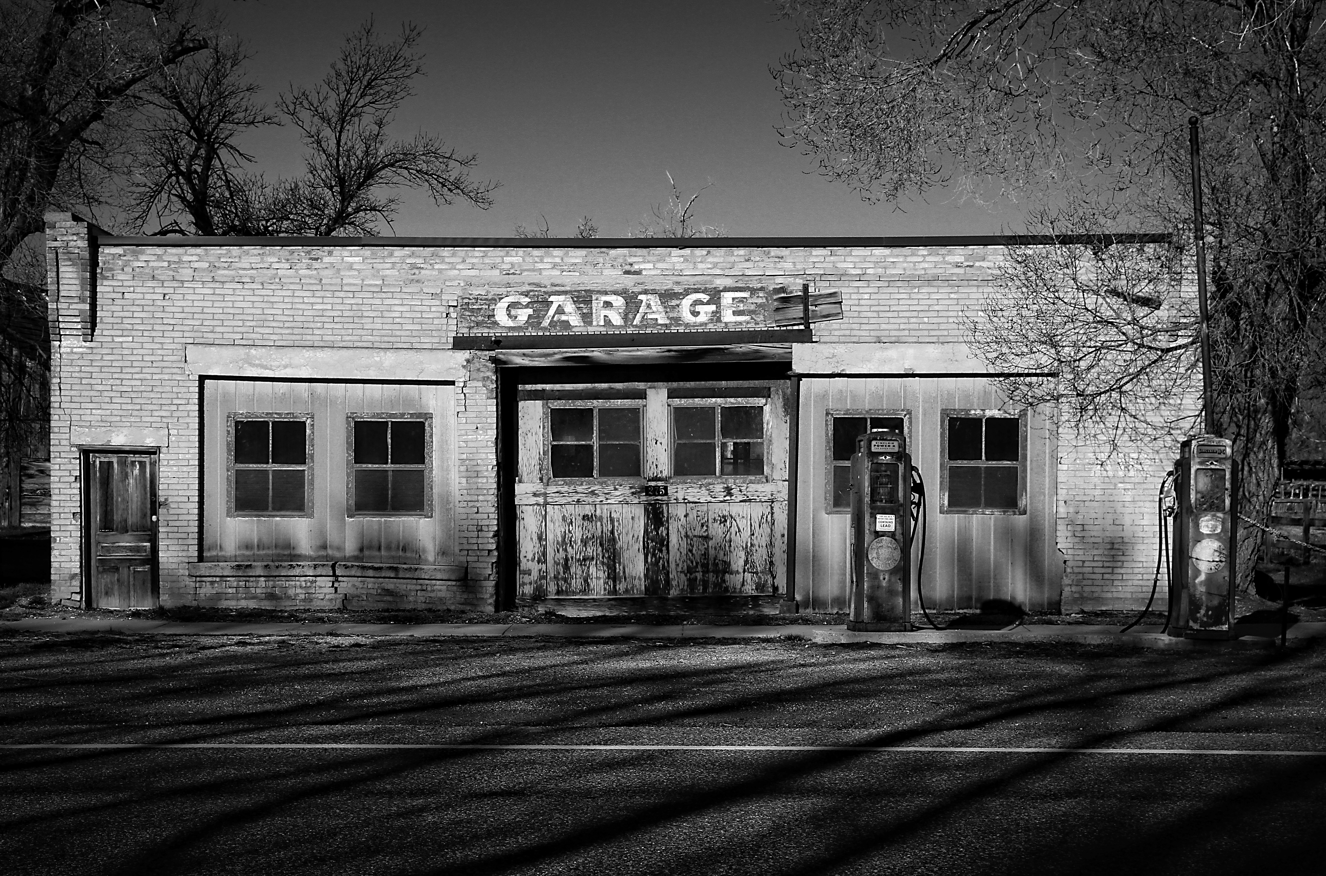

The MAFCA 2015 Lobsters and Lighthouses National Tour is memorable history as is our meeting schedule for 2014 – 2015. No meetings until September.

Julie and I, Don Bushart, Sam and Mary Ann LaLomia, and Doug and Bea Archer all enjoyed the Maine Tour. It came and went very quickly. Fortunately none of us experienced any mechanical trouble with our Model A’s that might have dampened our enjoyment of the Tour. I’ll have a DVD or slide show edited and ready for viewing for one of our meetings in the fall. Great fun we had!

Mark Harth mentioned at the recent picnic that MARC plans a National Tour for the Hudson Valley next year. Let’s plan to go! I looked over MARC’s web site but could not find any information about the Tour, not even a projected date, but we’ll surely see detail at some point so we’ll be discussing the Tour in the future.

Regarding the June picnic .. Bill Haag sent me this note: “… whoever brought the pasta salad to the picnic forgot to take it home with them. Also there were two serving spoons with it. I have the spoons and whoever they belong to let me know and will get them back to them.”

Enjoy your summer and everything that warm weather and Model A drives bring. Please be safe and healthy, see you in September or somewhere along the car show road ….
All for now, Jim

Picnic Report

See the photos! We enjoyed much good food, great chat, and nice weather!

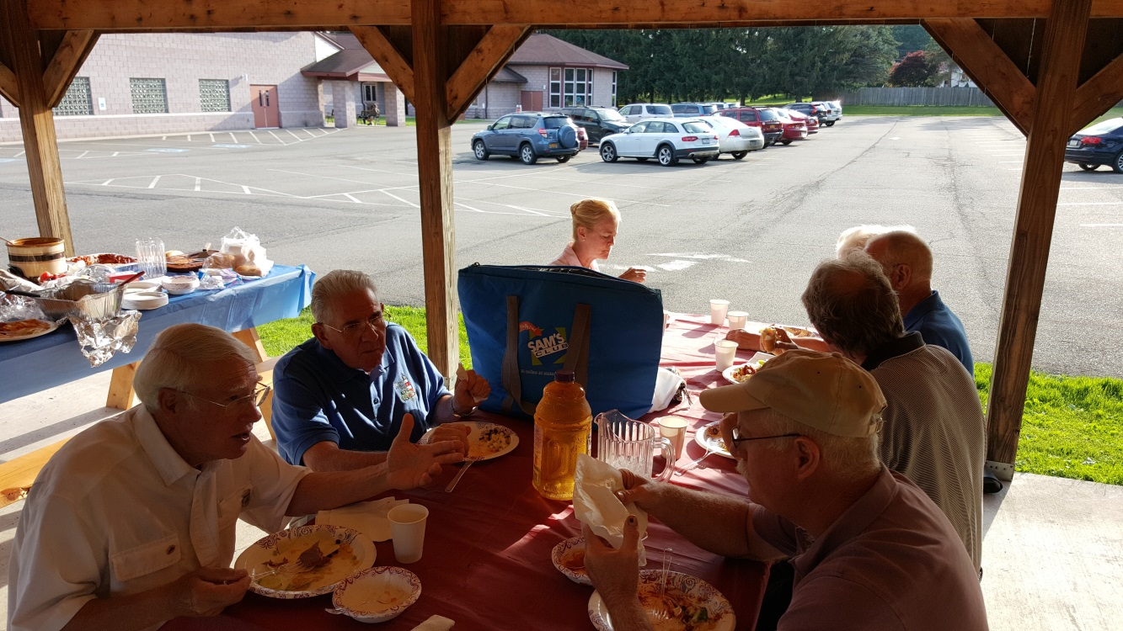

We gathered, we ate, we laughed, we enjoyed!
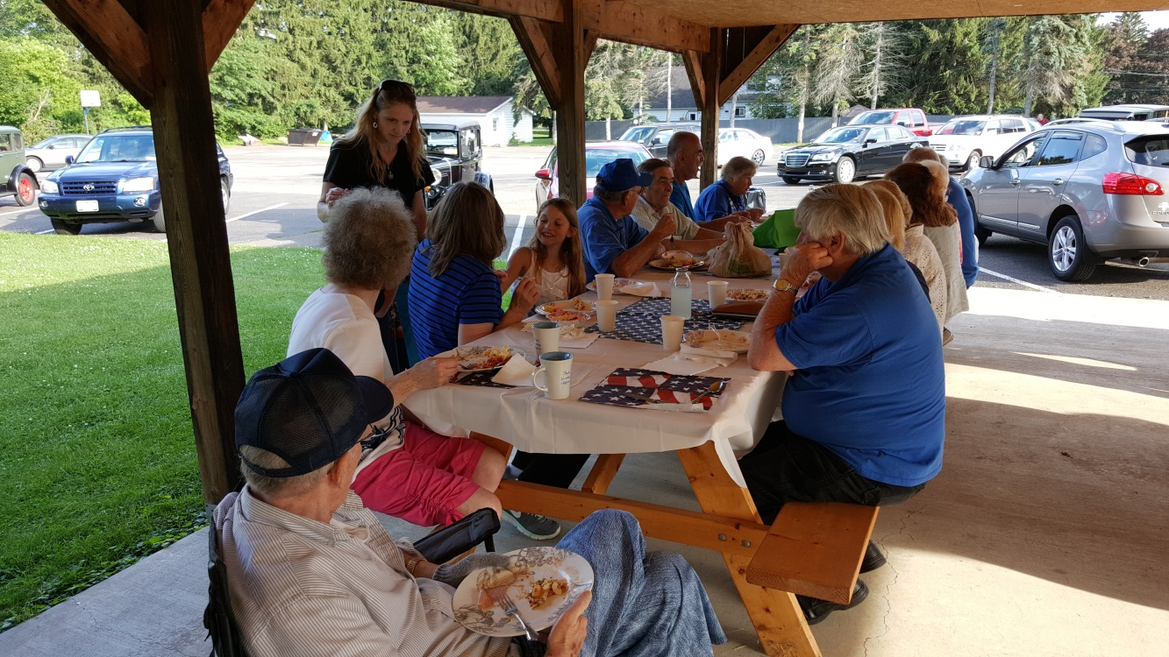June 16 Picnic

A Few Photos of the Lobsters and Lighthouses Tour (no order!)
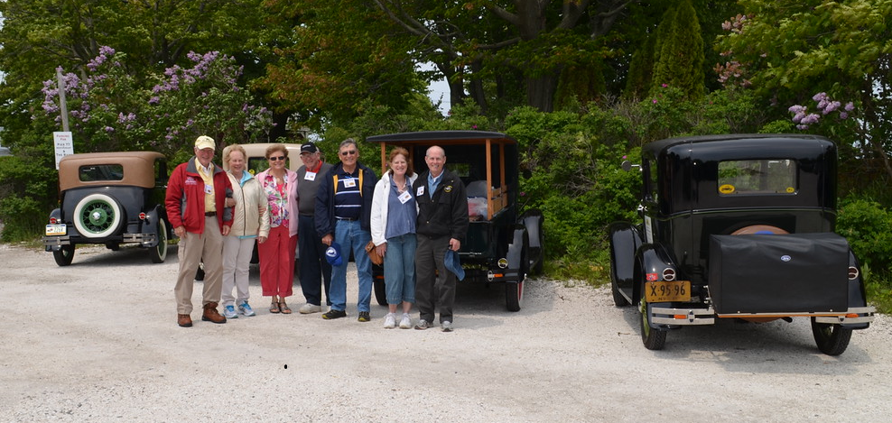Sullivan Trail A’s gang in Cape Porpoise, ME
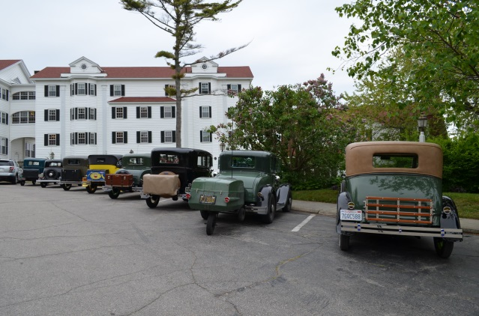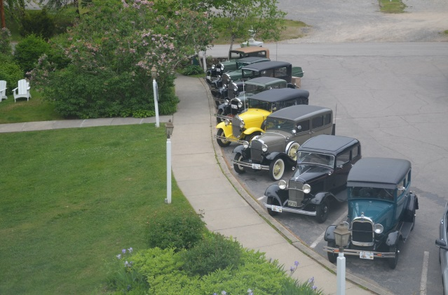
Colony Hotel, Kennebunkport, ME
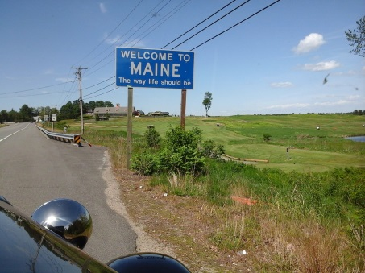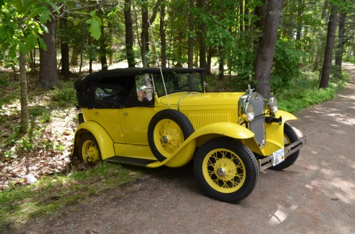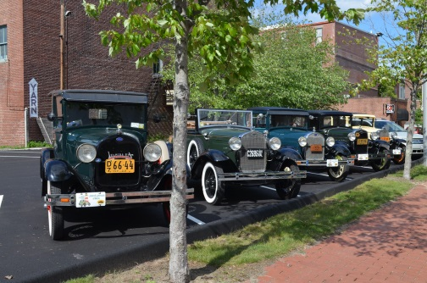
Miscellaneous
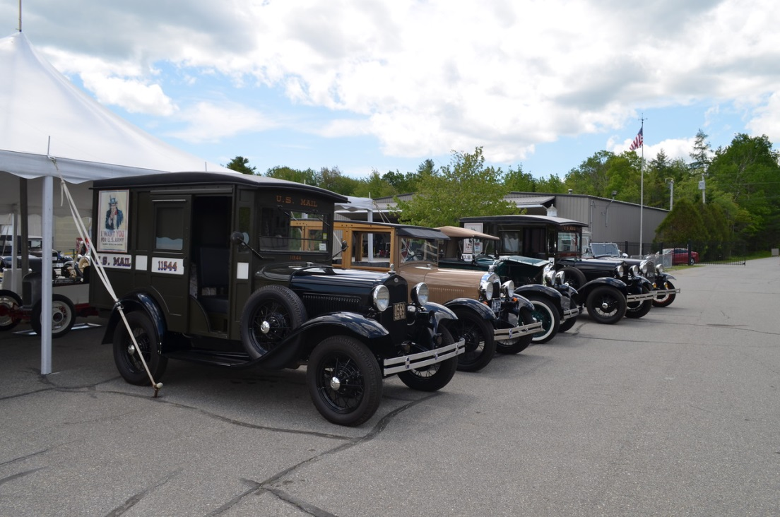

Owl’s Head Transportation Museum (see video link after photos)
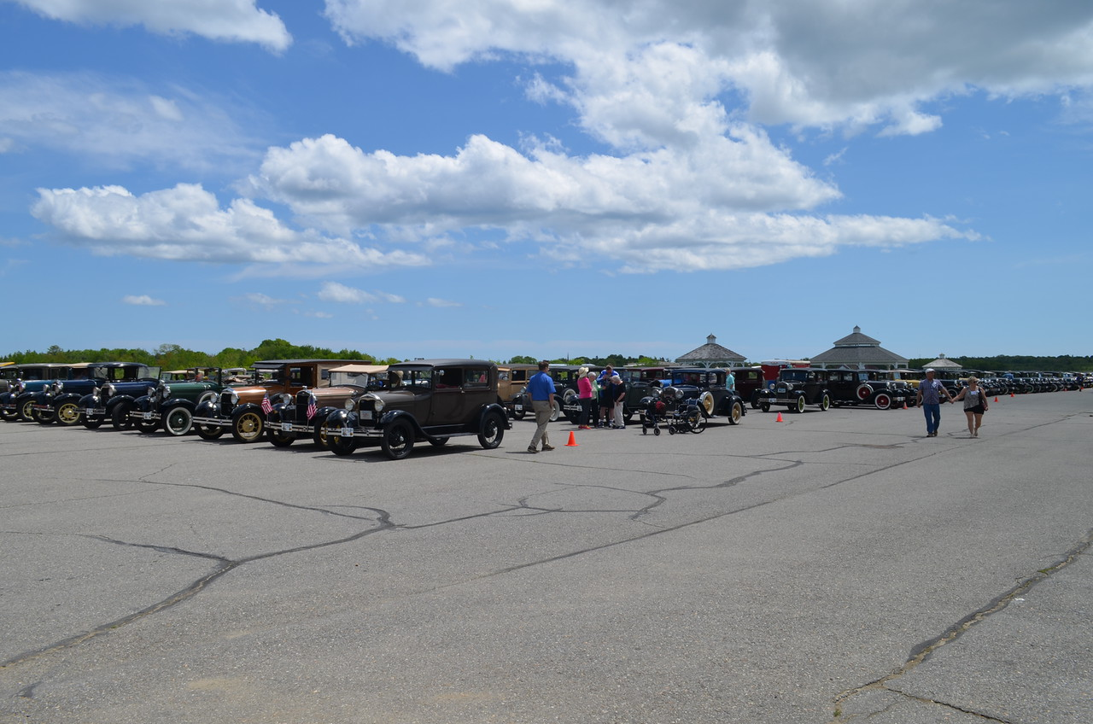
Owl’s Head Transportation Museum – 150 Model A’s?
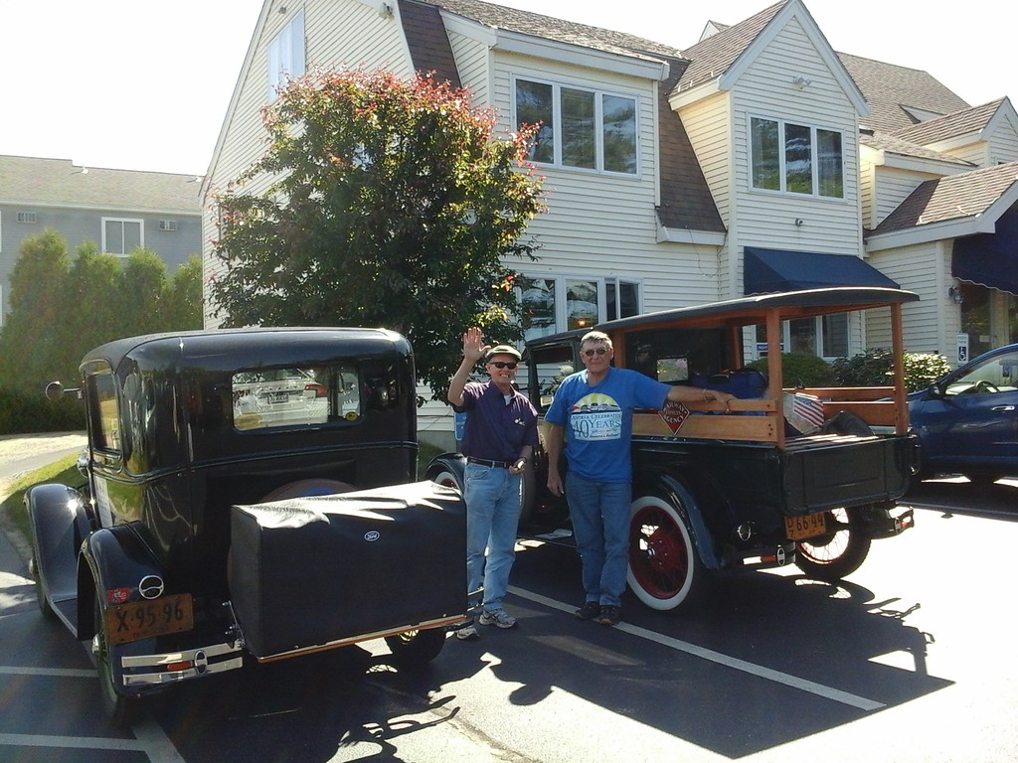

Jim and Don with Julie behind the lens, Wells, ME, first overnight in ME
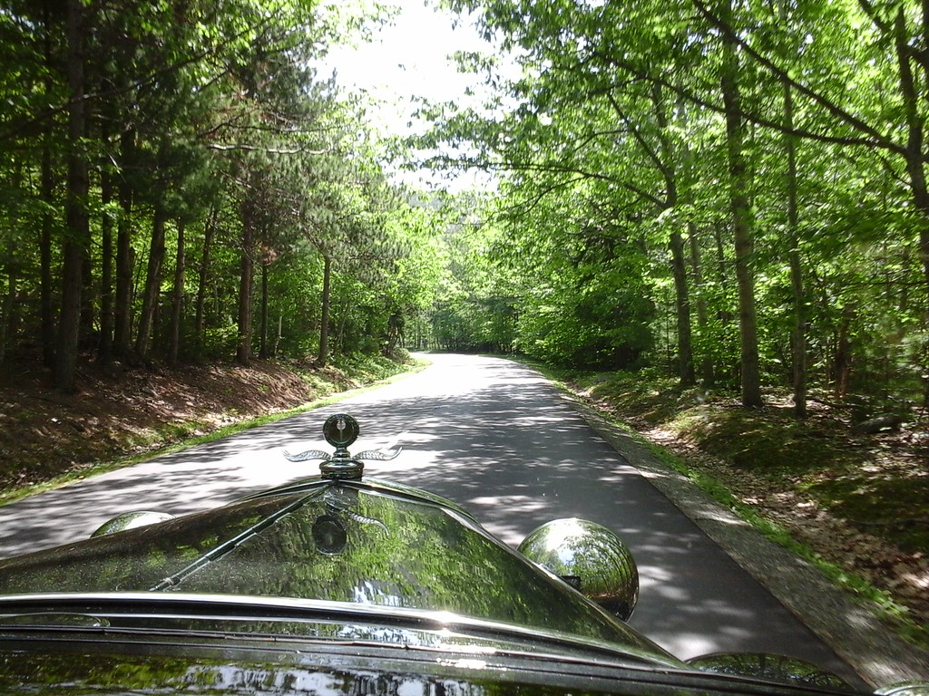
Henrietta with Jim & Julie ascending Cadillac Mountain
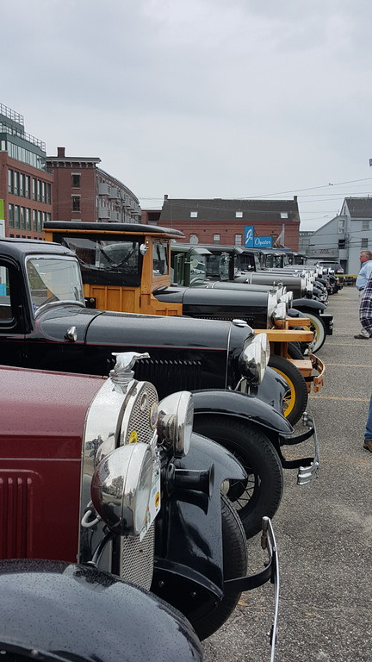 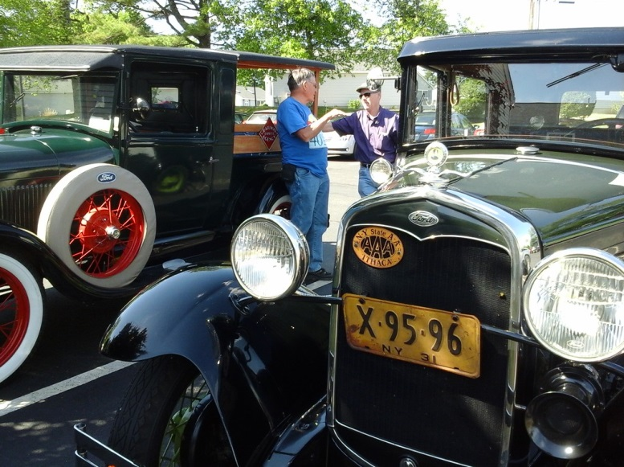 Portland, ME .. Model A’s parked Lunch Break
for Trolley and Boat Tours
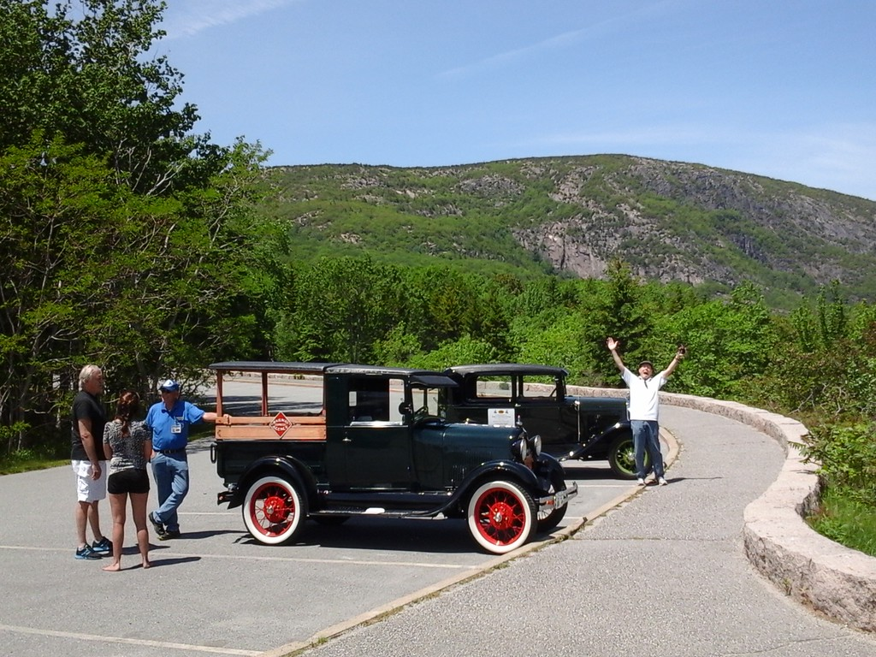
Cadillac Mountain pullover, Don chatting and Jim being silly
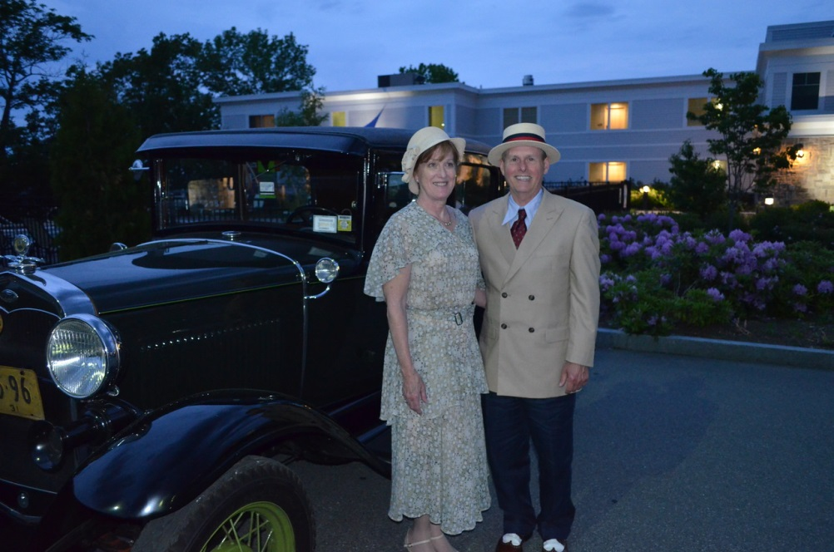
Jim and Julie after the Farewell Dinner
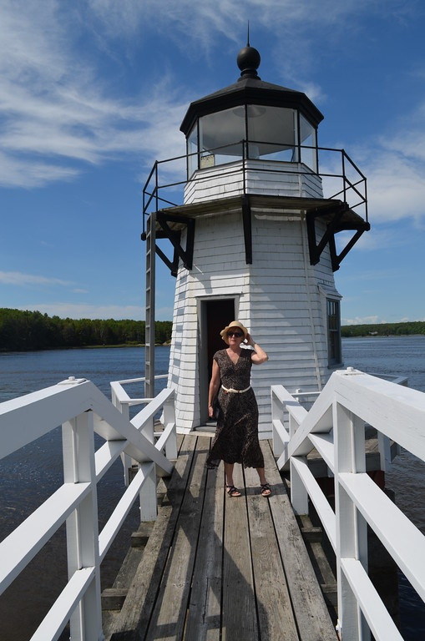
Doug and Bea
Farewell Dinner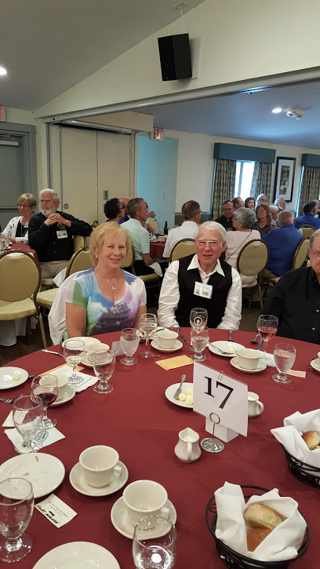
Sam and Mary Ann
Farewell Dinner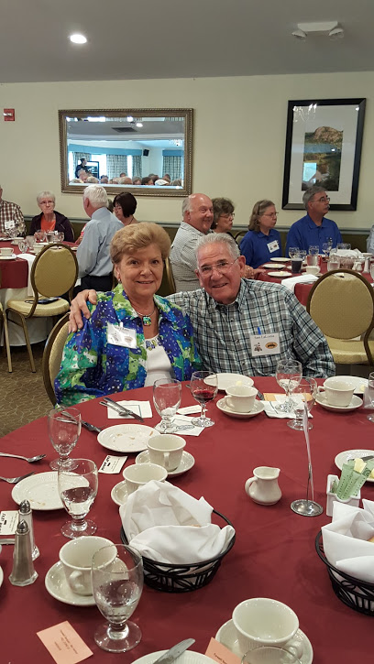
Julie at the Doubling Point Lighthouse

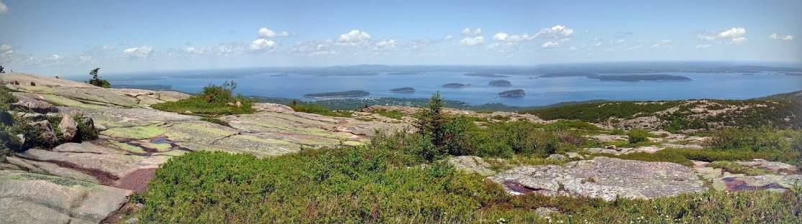View from Cadillac Mountain
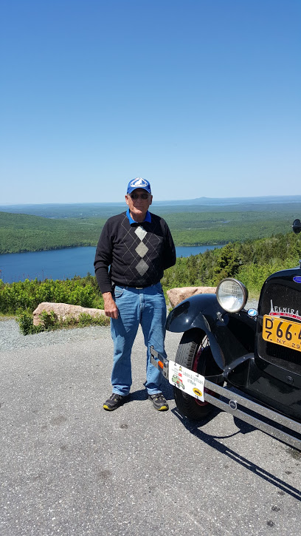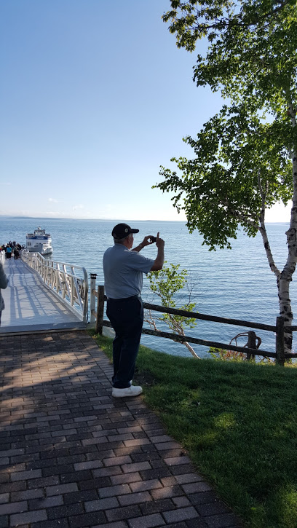
Don - Cadillac Mountain Sam snapping photos... Atlantic Oceanside Inn
Bar Harbor
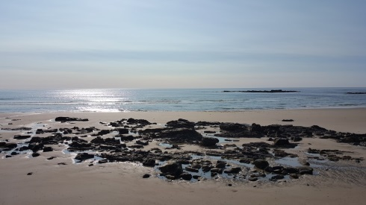 Miscellaneous 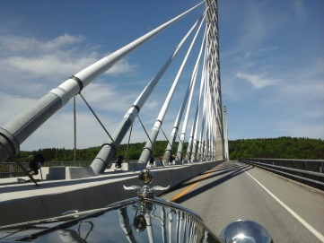
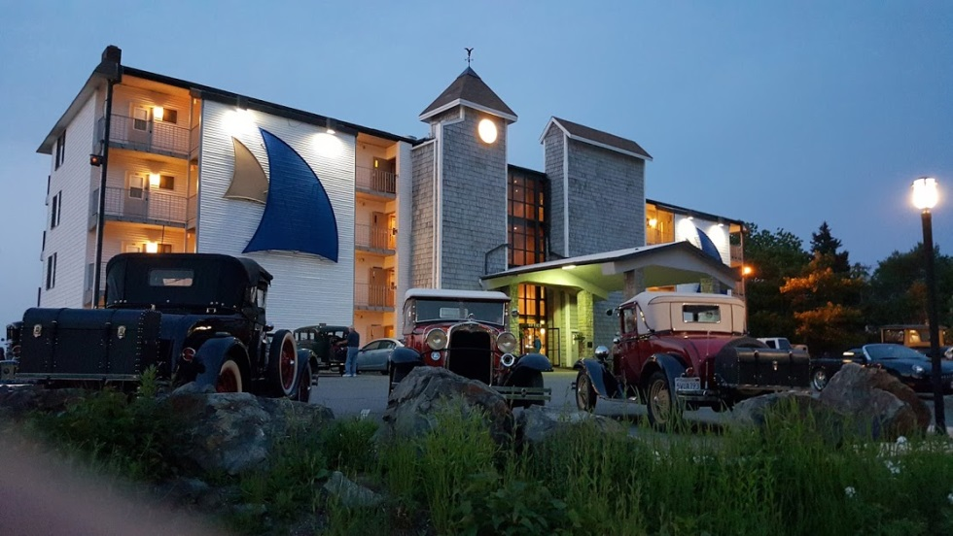

Atlantic Oceanside Inn Main Building

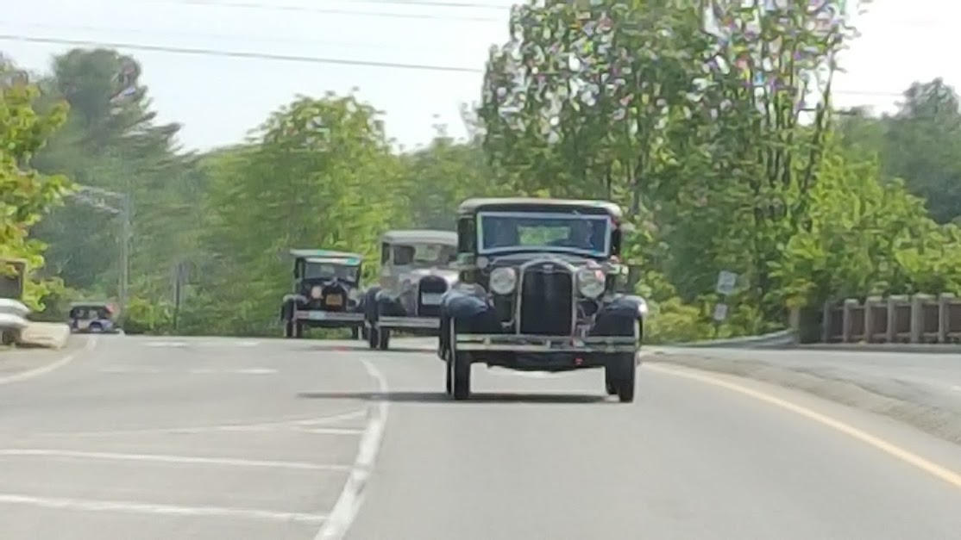

Archers, LaLomias, Don (and anonymous “A” in pursuit!) following Jim and Julie

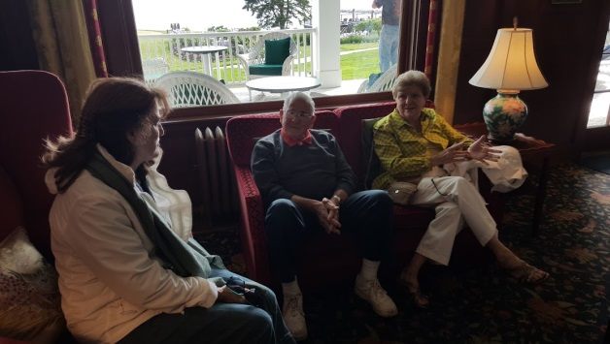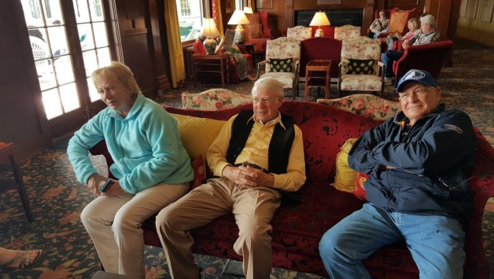

Sullivan Trail gang relaxing in the Colony Hotel lobby, Kennebunkport
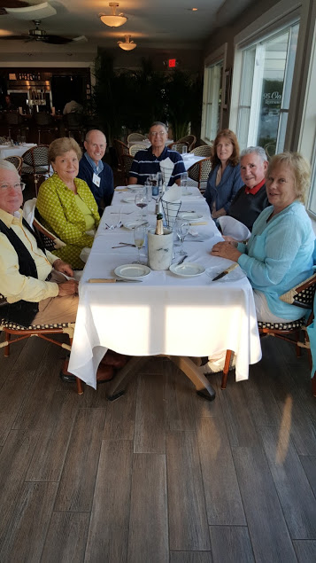

Cheers to Maine!
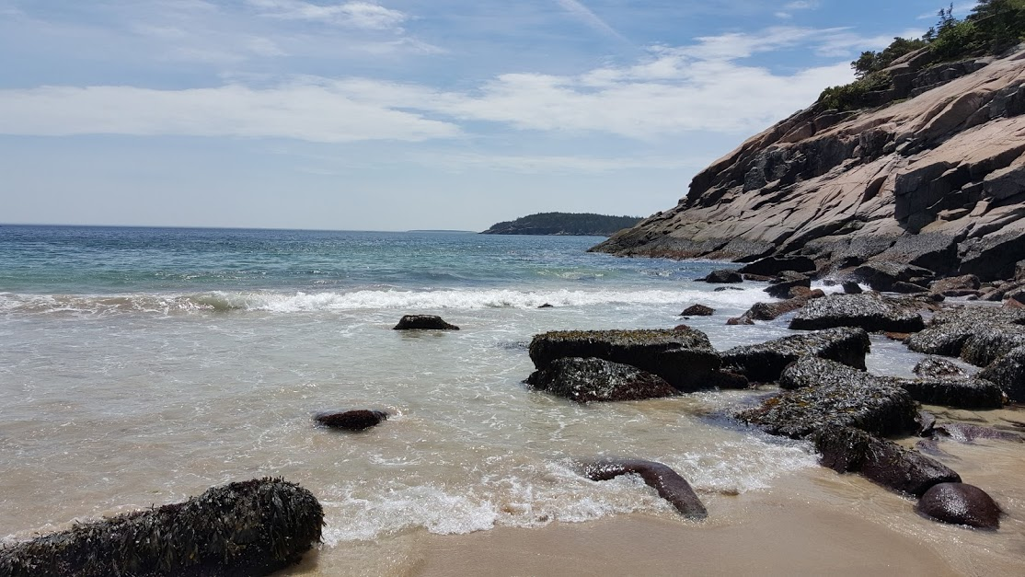

Ahhh, Sand Beach and the Atlantic
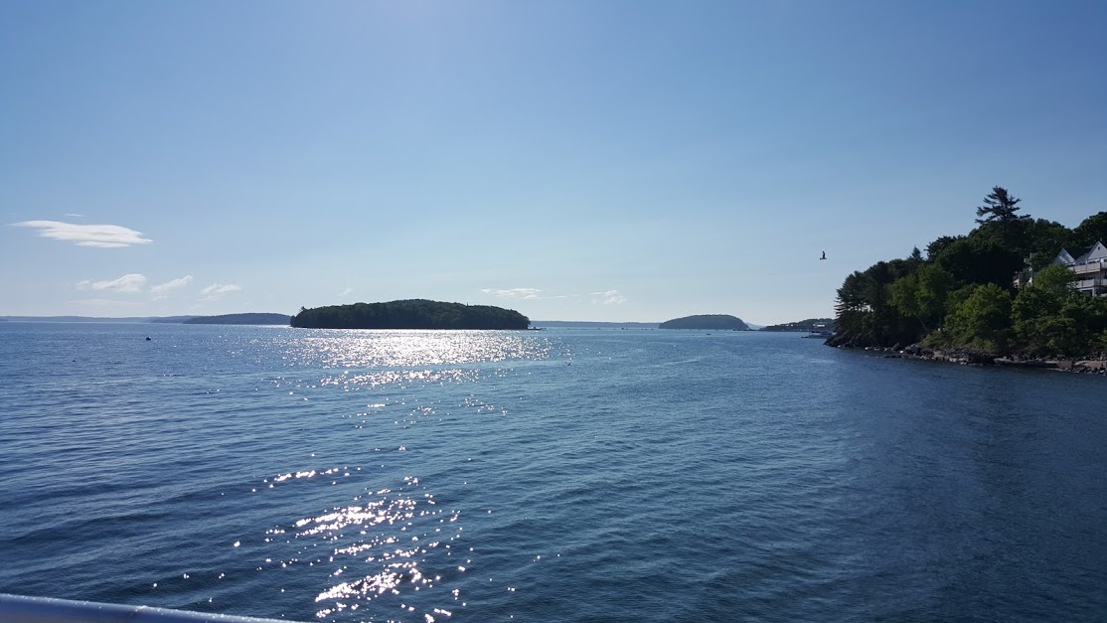
Guess ….
Sullivan Trail gang enjoying dinner at the
Nonantum Hotel in Kennebunkport
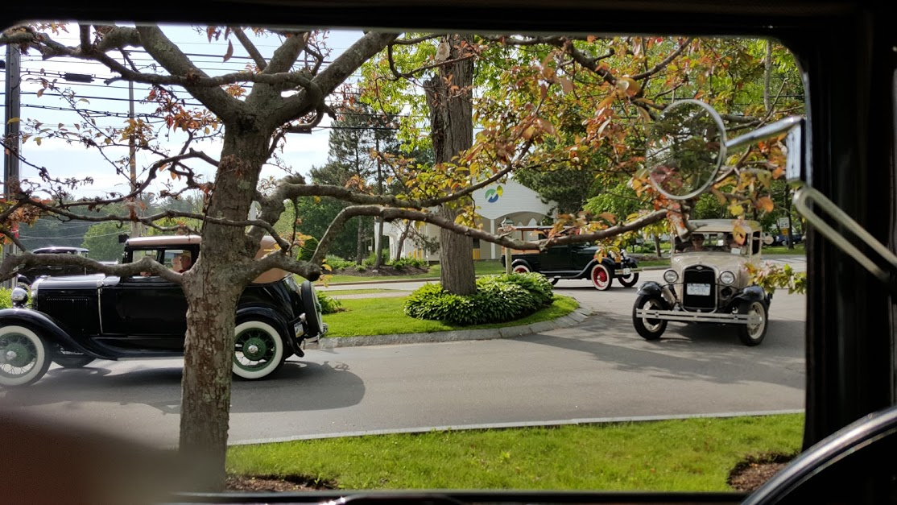
Archers, LaLomias, Don .. Freeport, Harraseeket Inn

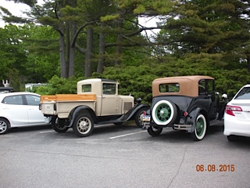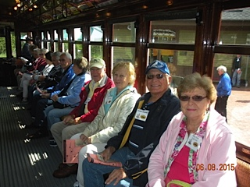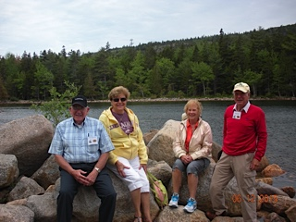
LaLomia’s & Archer’s wheels Seashore Trolley Museum The gang at Jordon Pond(?)

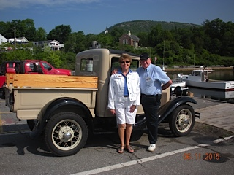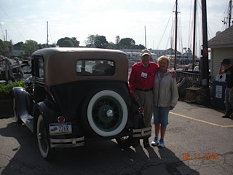
Guess! Guess!
Good bye Maine!!!

Video Links
- Video link: Jim and Julie driving into the parking area of the Owl’s Head Transportation Museum’s parking lot and greeting all the other Model A’s: https://goo.gl/photos/9asgvHbzSaSi54ns9
- Video link: Henrietta motoring through Vermont to Maine, Don pushing from behind: https://goo.gl/photos/o7VimNSPRkMyNQmH9
- Video link: Henrietta descending Cadillac Mountain (note biker’s hand signal): https://goo.gl/photos/MgBURrMw1KwzUmVXA
- Video link: Sullivan Trail gang after lunch in Cape Porpoise headed back to Kennebunkport: https://goo.gl/photos/ANUGHggVnVaaNAga9

2015
June 27th Big Flats, NY Community Days Line up 3:30PM at Big Flats Elementary School
June 27th. Mansfield, PA Beiter's Home Center Parking Lot Tyoga County Motor Club 21st. Annual Car Show 9am - 4PM Reg. $10 Contact Duane Anderson 570-638-3176 or Lewie Covert 570-724-1329
July 4th. Van Etten, NY Car Show McDuffy Hollow Road,( County Road 48) off St Rt. 224
July 3rd.-5th. Millport, NY State Route 14 22st. Annual Benefit for the Arctic League, Seneca Santa and diabetes featuring Antique Tractors, Engines, Antique Cars & Flea Market Frank Johnson 607- 535-2261
July 8th. Waverly, NY Annual Car Show at the E. Waverly Park 4PM – 8PM Contact Katie 607-565- 3570
Rain date July 15th. Dash Plaques first 110 cars Fire House. 10AM – 3PM
July 11th. Geneva, NY White Springs Winery 4200 Rt 14 Show limited to 50 vehicles--Must be 25 years or older
Fee $10 11AM - 4PM 315-781-9463 www.whitespringswinery.com
July 12th. Muncy, PA International Motor Truck Gathering 10AM - 5PM 96 Industrial Park Rd.
More info Lenny & Lanni Ohnmeiss 570-435-0647 E-Mail IHMUNCY@yahoo.com
July 12th. Arkport, NY Chemung Valley Region AACA 59th Annual Antique Car Show Arkport Athletic Field Contact Randy Guild 607-295-7327
July 12th. Owego, NY 42nd. Annual Cars in the Park, Hickories Park www.triplecitiesstreetrods.com 8 AM – 4PM
July 17 -19 Horseheads, NY Chemung Valley Old Timers 36th. Antique Tractor and Flea Market Chemung County Fairgrounds www.chemungvalleyoldtimers.com
July 18th. Horseheads, NY American Legion 72 Old Ithaca Road Car Show 9AM - 3PM Fee $8
Contact Andy Dominick 607-398-6012 Rain Date July 19, 2015
July 17-19 Syracuse, NY Syracuse Nationals at the Fairgrounds www.rightcoastcars.com/syracuse-National.php
July 24-26 Watkins Glen Glenora Wine Cellar Vintage car race
July 25th. Hector, NY Auto Show at the Fairgrounds Reg. 9AM – Noon Contact K. Hillard 607-546-4941
July 26th. Nichols, NY Bedrock Car Show 11 Annual Show Car Reg. $10 9AM – 4PM
Flea Market $10 per 15’ x 15’ space South of Nichols at the State Line NY RT 282/ PA RT 187 www.windham19fire.com Doug Soden 570-247-2512 Flea market $10 per 15’ x 15’ space
July 31-Aug 2 Macungie 52nd. Annual AACA meet 610-967-2317 www.awkscht.com/
Aug. 1st. Port Byron, NY 10th. Annual Car Show Pre Reg. $8 Vendor Table $10 David Ware 315-406-1163
Cayuga Country Cruiser Benefit Fire Department
Aug. 5 -8th. Canandaigua 55th. Pageant of Steam off Rt 20 Antique Tractor show and Large Flea market www.pageantofsteam.org
Aug 9^{9th} Auburn NY AACA History on Wheels Downtown Auburn 9 AM to 4PM Contact Jim 315-253-4357
Aug. 6-9th. Cortland,NY Brockway Truck Show 16th. Annual www.brockwaytrucks.org
Aug. 9th Interlaken, NY 28th Car Show 8AM – 3PM Cash drawings mbarkee@fltg.net
Aug. 16th. . Marion NY Wayne Drumlin Region 36th annual Car Show E-Mail dndbed@gmail.com
Aug. 16th. Owego, NY Hickories Park Tioga Region AACA 30th Annual Car Show and Flea Market 9AM – 4PM
Bob 607-761-0897 www.tiogaregion.com
Aug. 23rd. Elmira, NY Brand Park 17th Annual hours 12 to 4 607-734-9547
Aug. 22nd Spencer, NY Keturi Park 30th Annual parade and car show. FREE Parade 10Am Car Show 9-2
Contact Doug at 607-589-6512
Sept. 6th. Moravia NY Fillmore State Park 39th. Annual Car Show & Flea Market PRE-REG SUGGESTED
gary@chronicleguidance.com
Sept. 11th. Watkins Glen Down on the main drag US Vintage Grand Prix They will run the old race track
Sept. 13th. Wampsville NY 55th.^{t} Annual Car Show Mohican Model A Club. Large Flea Market www.mohicanmodela.org
Sept. 20th. Warren Center, PA CAR SHOW Cruise-In 11AM till ?? 9 th Annual Jeff Treadwell tread40@yahoo.com
- September 19, 2015 -- Worldwide International Model A Day 2015 Hosts: MAFCA/MARC -
Sept. 19-20 Troy, PA Heritage Festival 18 th. Annual www.paheritagefestival.org
Sept. 19st. Nichols, NY 5th Annual Car Show in Tioga Downs 9AM-4PM Reg. $15 shoffman@tiogadowns.com
Sept. 26th. Cayuta NY GLASS SHOP north of Alpine Junction on St Rt 13. 10-3 Registration $5 Benefit of Boy Scout Troop 50 Bring canned goods for food pantry and returnable bottles and cans for Scout Troop #50
Sept. 27^{tth.} Painted Post, NY GST BOCES Coopers Plains Campus 8th Annual Car Show 10-3 Rain or Shine
Reg. $7 by Sept. 21st.. Phone 607-654-2227 E-Mail jdekoeyer@gstboces.org
Oct 2 – 4 FALL CARLISLE
Oct 7-10 FALL HERSHEY

- Thanks to Ginny Bruckner and the Twin Tiers Vintage Car Club for this detailed summer schedule -

The Sullivan Trail A’s News

Did you know …

… that there are no meetings during the summer?!

Technical Tip:
During the summer use Rainex on your windshield, check your lug nut tightness and tire pressure regularly, change your oil and grease per Ford’s recommended schedule, keep some basic parts and tools in your “A”, carry your cell phone with you in your “A”, stay in touch with Sullivan Trail members, and grab a friend or two and head for your nearest ice cream stand in your A’s!

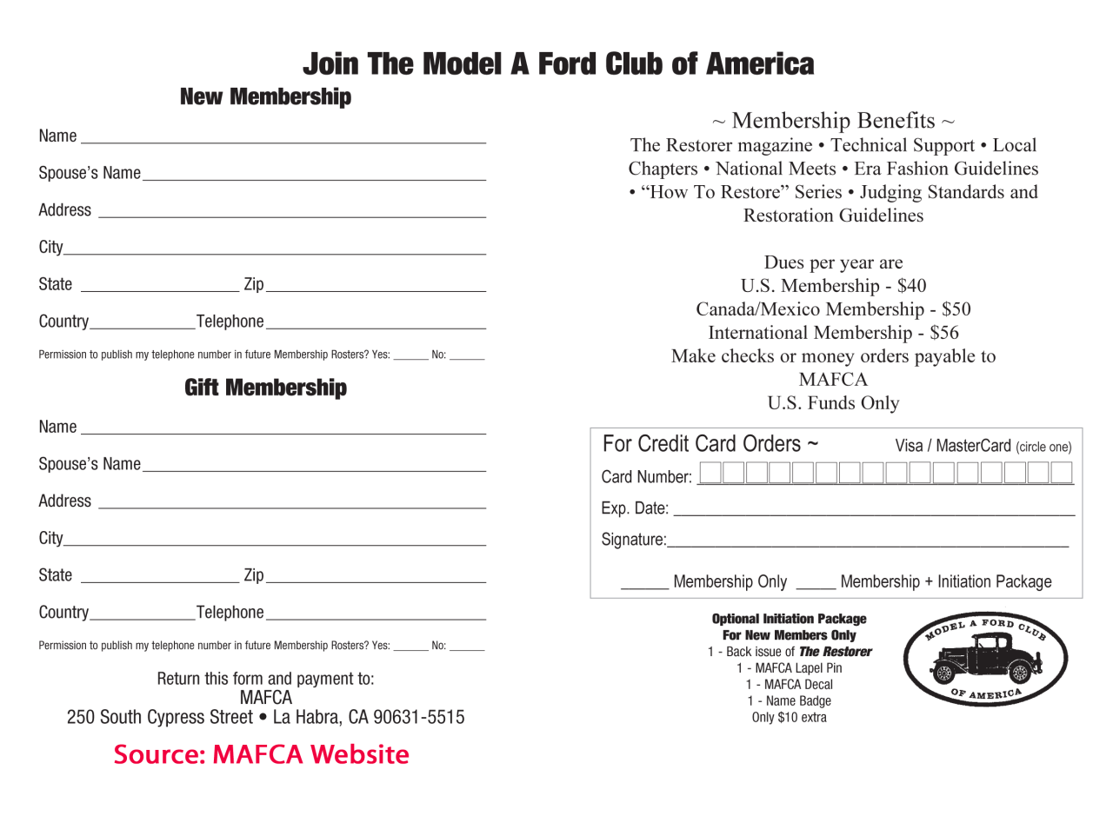
The Sullivan Trail A’s News

Did you know … this(?) about

