The Sullivan Trail A’s News

“Coming together is a beginning; keeping together is progress; working together is success.”
- Henry Ford
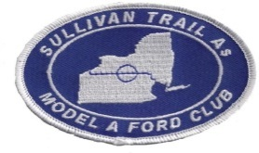 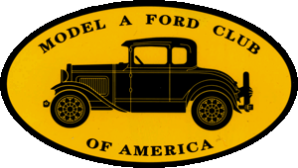 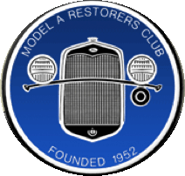 http://www.sullivantrailas.com 1903 1927–1931 February 2016

2008 4,849,340 Produced Volume 9 Issue 2
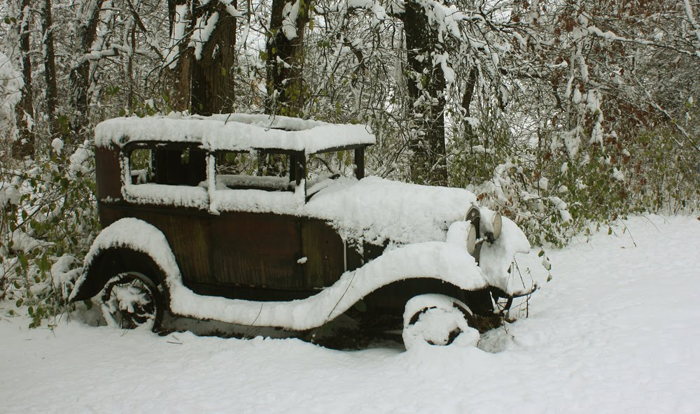
No heater in this A, must get cold inside when it’s on the road!

~~~~~~~~~~~~~~~~~~~~~~~

President

Jim Morris
jim.morris2831@aol.com

Vice President

Don Bushart

dbjb806@icloud.com

Treasurer

Mark Harth
bearfarm14818@gmailcom

Secretary

Beverly Harding
1stmafc@gmail.com

Director At Large

Bill Haag
fingers5n5@aol.com

Newsletter Editor
Jim Morris

Website Liaison

Jerry Wilcox

jerrywilcox55@gmail.com

Webmaster
Mike Horning
mhorningpsu@gmail.com

~~~~~~~~~~~~~~~~~~~~~~

Sullivan Trail A’s Meetings:
- Monthly
- 2nd Tuesday September - June
- 7pm
- United Methodist Church
1034 W Broad St
Horseheads, NY
~~~~~~~~~~~~~~~~~~~~~~

In This Issue
- From The President’s Garage
- 1-9-16 Meeting Minutes
- Upcoming Events
- A meeting with coils (huh?)
- Did you know …?
- Technical Tip: carb adjustments
- For Sale/Wanted
- Winter fun
- Speaking of elections
- MAFCA Membership

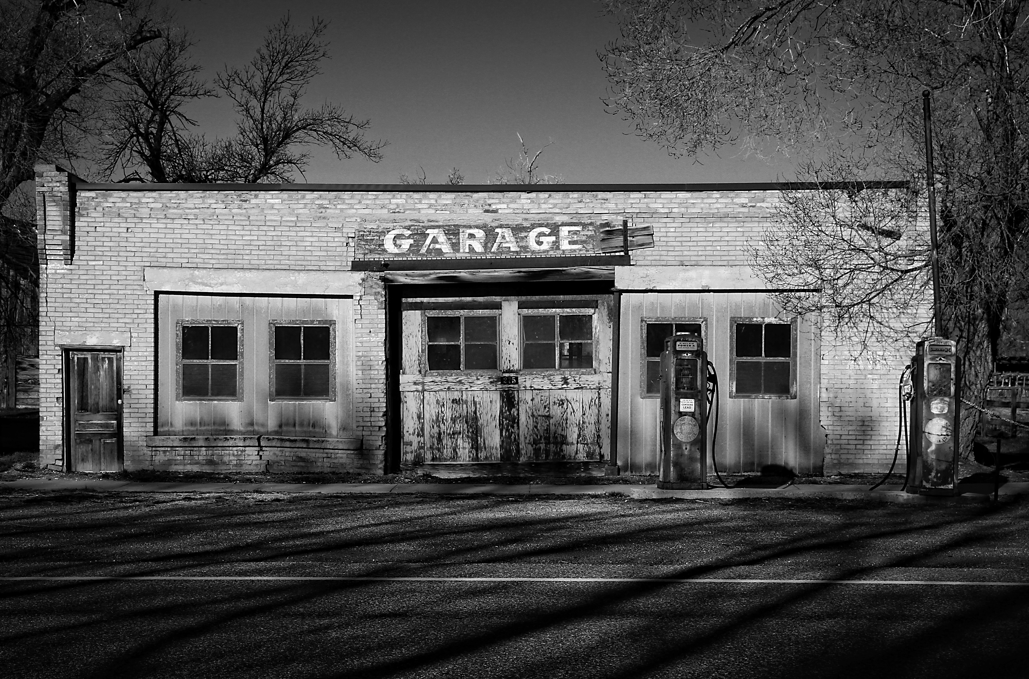

FROM THE PRESIDENT’S GARAGE

The drive home after our February 9th meeting was a wild ride. All of us have enjoyed fairly mild weather this winter, if you can call it winter, but that particular Tuesday night involved heavy snow to and from Horseheads (I live on the northeast side of Ithaca) and 5 mph traffic going down NYS Rt. 13 between Newfield and Ithaca. I was happy to get home!

We had a good discussion at the meeting about the future of our web site. Currently the web site is lying dormant and out of sight while we figure out whether we can and want to reactivate it. We’ve not been able to keep the site current with up to date photos, newsletters, and other Club related information so several of us have been nosing around for help and ideas on how to get the site up and running with minimal cost to the Club. Jerry Wilcox, our web site liaison, has helped significantly with this effort. Although Jerry couldn’t come to the February meeting I presented an update on our progress and asked that members think about what I shared and be prepared at the March meeting on the 8th for more discussion and a vote on killing or resurrecting our web site. Bottom line: we have a green light from our web master Mike Horning to hand the web site over to Nathan Reimer, a local to the Ithaca area and acquaintance of Jerry’s, for reactivation. Mike updated and re-designed the site last year so it’s in good shape to be put into use with minimal fixes. Annual cost to host the site and to keep our domain name will be under $50, Nathan’s charge to work on the web site would be at the rate of $50/hour but Jerry and I believe that there will be little work to do. We also have anonymous pledges that total $650 to off-set startup cost so I’m optimistic that we can get the web site up and running with minimal costs to the Club. Beverly, Jerry, and I will be trained on how to upload photos, newsletters, and the like to the new site and we won’t charge the Club for our help! Please come out for our next meeting to participate in this important discussion.

All for now, Jim

Minutes of the February 9, 2016 Meeting

Meeting was called to order at 7PM by President Jim Morris. Thirteen members were present.

- Motion to approve Secretary’s report by Tom, second by Bruce. Motion carried.
- Treasurer reported the balance. Motion to approve Treasurer’s report by Don, second by Bill. Motion carried.
- The Homer Memorial tour is scheduled for May 21 & 22 to the Lumbermen’s Museum in Galeton, PA. Mark contacted the Penn Wells Motel in Wellsboro regarding room rates. Manager Dave Cox quoted him a rate of $79.95 per night for double bed and $114.00 for a suite. This would include the Sunday brunch. You can call the Penn Wells at 570-724-2111 to make reservations. Dave said he would block off an area for our cars to be parked. Don will be getting additional information regarding the Tioga Central RR. More discussion at next month’s meeting regarding other things to do on the tour.
- Jim and Jerry have been working with Nathan Reimer of Reimer Consulting regarding our website. He would charge about $50.00 per hour for working on site. Mike Horning said he will work with Nathan to migrate our current website so we do not have to start over. Pros and cons of the issue were expressed. There will be more discussion at the March meeting.
- A possible tour to the Sayre Historical Society was mentioned. This will be discussed at a future meeting. There will be a pork loin dinner on Feb 20 at the Newfield Fire Hall from 5 to 7PM.
- Possible fund raising idea is to have members bring in items they would like to sell and then donate some or all of the proceeds to the club.
- Jim has reserved the second spot at Filmore Glen for those interested in selling items at the show in September.

Thank you Don for the delicious refreshments. Harth’s will bring the refreshments for the March meeting.
Don won $16.50 in the 50/50 raffle.
Motion to adjourn at 8:15 by Carole.
Respectfully submitted,
Bev Harding, Secretary

Carole added this about the Penn-Wells Hotel at press time: Double bed ~$85, queen ~$100, king and 2 doubles ~$120. $17 Sunday brunch included with room. Currently the Hotel has 14 rooms available at the lowest rate. There are other options, you can also ask about packages. They also have an indoor pool and exercise room at their sister facility for us to use. Call the Hotel to get your exact rate.

2016
- May 21/22, Homer Memorial Tour to the Pennsylvania Lumber Museum, an overnight in Wellsboro, PA, there will be several hotels/motels to choose from. The Penn-Wells Hotel in Wellsboro is the informal ‘host’ hotel. Mark and Carole Harth obtained reservation information from the Hotel, see meeting minutes for details. The Hotel has plenty of rooms available so if you’d like to stay in this 1869 remodeled Hotel call now for reservations: 1-570-724-2111 Feel free to contact Mark or Carole, who spoke with Hotel owner Dave Cox about the Club’s stay, for more information about accommodations (available rooms, meal options, etc.). 863-899-7089 or bearfarm14818@gmail.com
- The MARC 2016 National Tour will be held in Newburgh, NY from September 19 to September 22. See MARC’s 2016 calendar here: http://model-a-ford.org/calendar/ and for the Tour here: http://theflyingquail.weebly.com/national-tour-2016-hosted-by-hvmarc-inc.html
- MAFCA Calendar for 2016-17 can be found here: http://www.mafca.com/calendar.html
- Stay tuned for a full listing of local/regional events in 2016

A Meeting With Coils

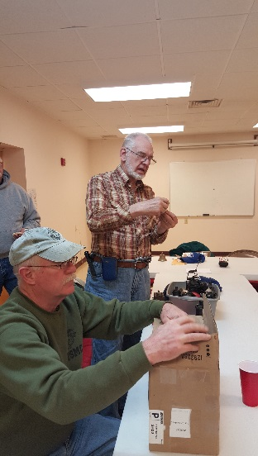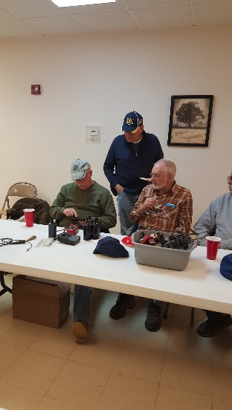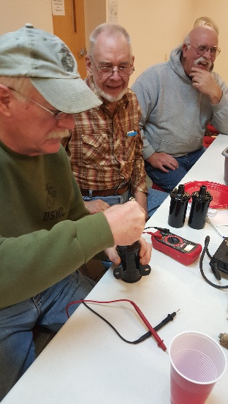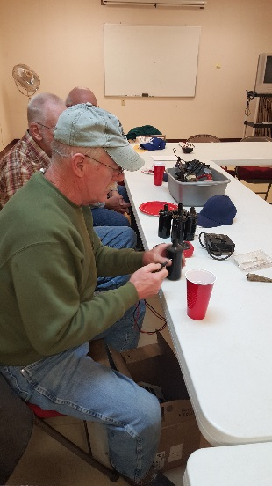
Larry and Bruce Larry, Don, Bruce Larry, Bruce, Tom By now you can id ‘em!

At the last meeting members brought in coils that had been collecting dust and our two primary “A” engineering gurus made quick work of “bench” testing about a dozen coils. The bad news is that most flunked the testing. The good news is that they go from the garage shelf to the trash bin making more room on the shelf for other treasures!
Thanks guys!

The Sullivan Trail A’s News 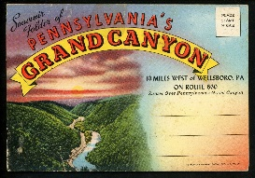 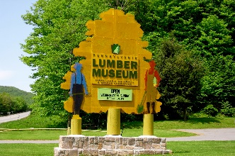

Did you know …

…this about the Penn-Wells Hotel in Wellsboro, PA?
The Penn Wells Hotel & Lodge proudly welcomes guests to Wellsboro, Pennsylvania, with a long tradition of gracious hospitality, comfortable accommodations, convenient location and personalized service. The Penn Wells’ staff takes great pride in the distinct character of Wellsboro and the beauty of the Pennsylvania Grand Canyon and surrounding countryside and love nothing better than sharing both with our guests.
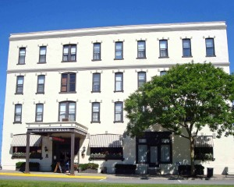

The Historic Hotel, built in 1869, is one of Wellsboro’s most recognizable landmarks. The current building, which was restored in the 1920s, has 73 character-filled guest rooms of varying sizes and types. Our elegant Lobby and Mary Wells Dining Room transport guests to a bygone era where welcoming staff and friendly locals remain the norm. The cozy and inviting full-service Lounge sits adjacent to the Hotel lobby and offers a full selection of classic cocktails, beer and wine for winding down after a busy day of travel, recreation or business.
The recently renovated 89-room Penn Wells Lodge sits just two blocks down Main Street and offers contemporary accommodations, including new suites and complimentary breakfast for guests. Our indoor pool and fitness center, travel market, convenient business center and guest laundry facilities are located at the Lodge. These amenities are available to guests of both properties.
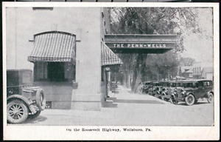
Both the Hotel and Lodge are situated in the heart of Wellsboro, along the iconic gas lit boulevard for which the town is so well known. Surrounded by miles of virtually untouched natural landscape, Wellsboro makes a perfect getaway vacation for lovers of the outdoors throughout the four seasons. Wellsboro also hosts numerous widely regarded festivals and events throughout the year, including the Pennsylvania State Laurel Festival in June and the ever-popular Dickens of a Christmas. So no matter what brings you to Wellsboro—business, travel or recreation—the Penn Wells Hotel & Lodge is glad to welcome you as our guest.
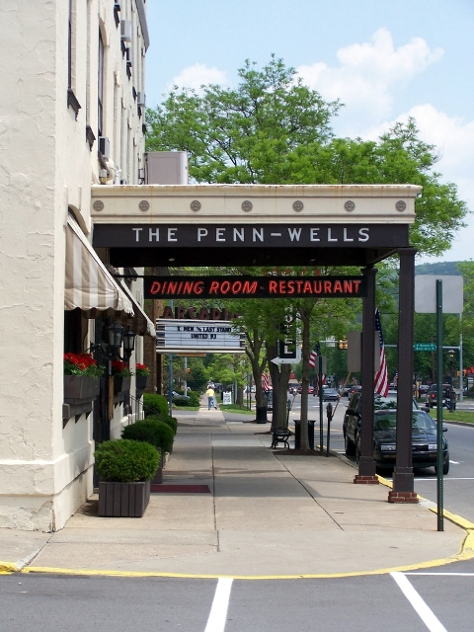
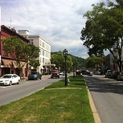

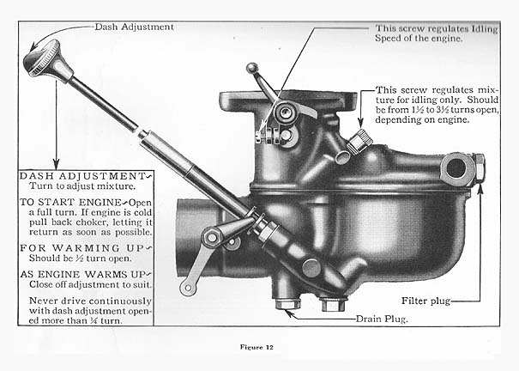

We could all use a reminder of basics now and then, eh?

1929 Model A Town Sedan, $15,000, contact Jeff Swan, 607-329-3174
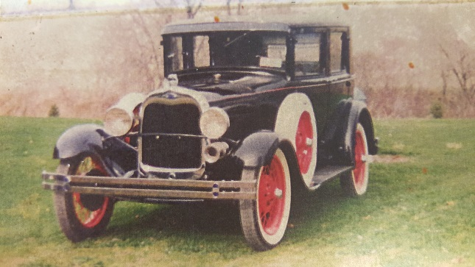

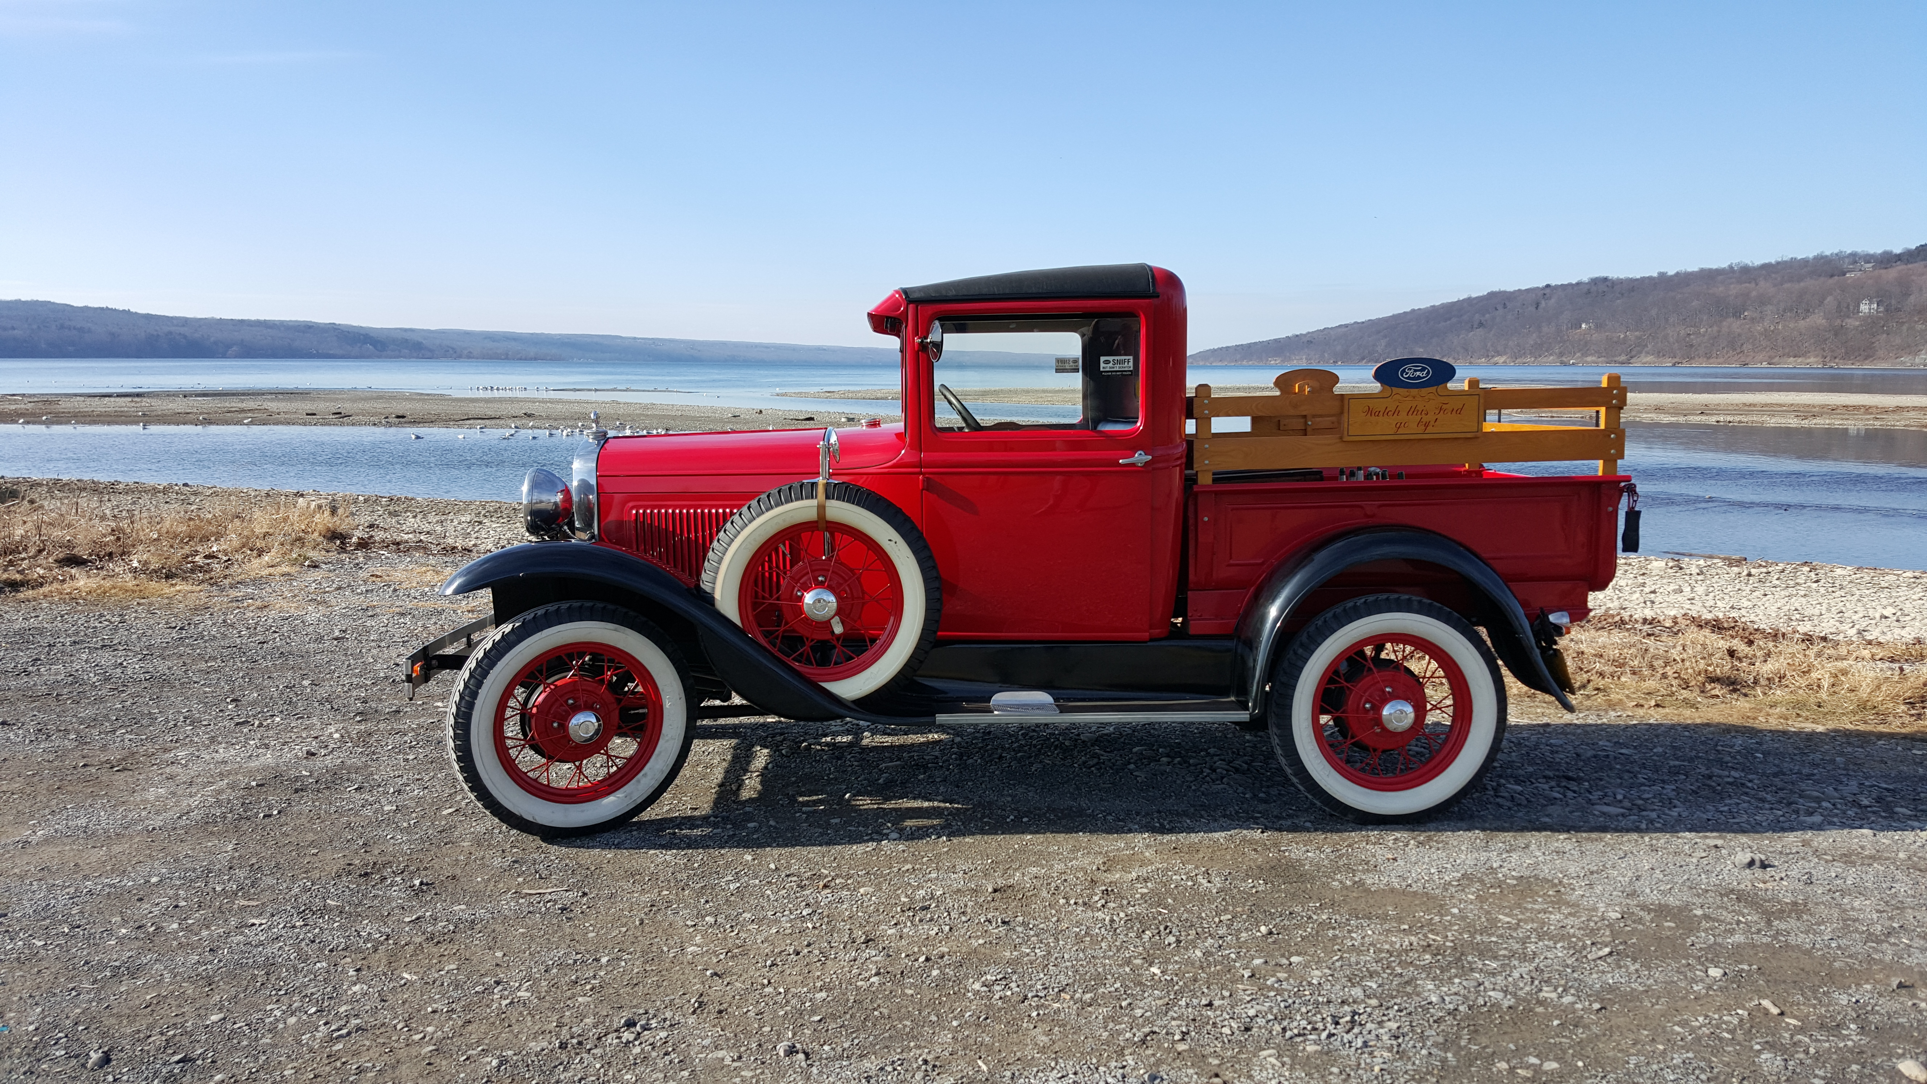
Winter Fun
Your Editor was able to take his ’31 Pickup for a Sunday drive on February 7th with his favorite co-pilot Julie. We found a nice spot to stretch at Myers Point on Cayuga Lake. Gorgeous February day. If you have any “A” related photos (or for sale/wanted items) you’d like included in the Newsletter please send them to me!

Speaking of elections ….. Ratified on August 18, 1920, the 19th Amendment to the U.S. Constitution granted American women the right to vote—a right known as woman suffrage. At the time the U.S. was founded, its female citizens did not share all of the same rights as men, including the right to vote. It was not until 1848 that the movement for women’s rights launched on a national level with a convention in Seneca Falls, New York, organized by abolitionists Elizabeth Cady Stanton (1815-1902) and Lucretia Mott (1793-1880). Following the convention, the demand for the vote became a centerpiece of the women’s rights movement. Stanton and Mott, along with Susan B. Anthony (1820-1906) and other activists, formed organizations that raised public awareness and lobbied the government to grant voting rights to women. After a 70-year battle, these groups finally emerged victorious with the passage of the 19th Amendment.
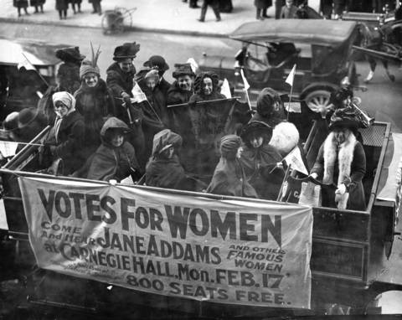

Some photos of the Pennsylvania Lumber Museum and an old, old postcard featuring the Pennsylvania Grand Canyon and the Penn-Wells Hotel.
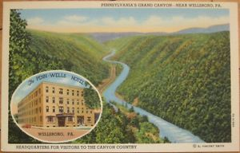

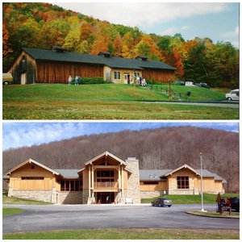

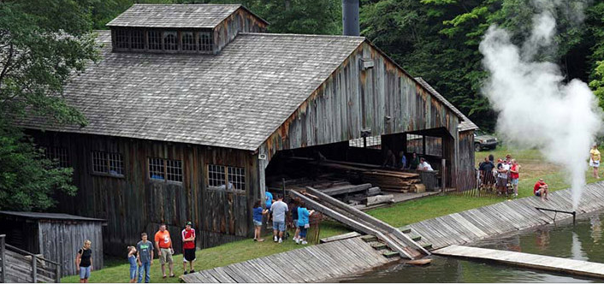

Before and after remodeling (2015)

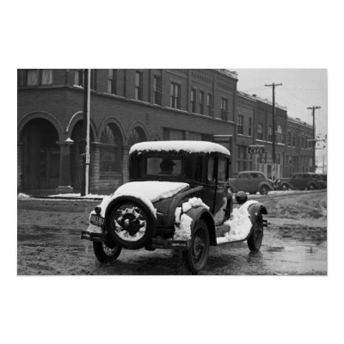
Bill Haag in his first Coupe c1938

